

**الجامعه المصريه للتعلم الالكترونى الأهليه**

**The Egyptian E-Learning University**

**Faculty of Computers & Information Technology**

**Email Spam Filter**

**By:**

**Abdelrahman Ahmed Shaker (ID: 20-01531) Karim Yasser Gaber (ID: 20-00062)**

**Youssef Ashraf Shawky (ID: 20-00627) Mohammed Ehab Sayed (ID: 20-00286)**

**Mohamed Ahmed Fargaly (ID: 19-01215) Nada Rafek Nabeh (ID: 20-01539)**

**Merna Sayed Hussein (ID: 20-00626)**

**Under Supervision of:**

Dr. Mayar Ali

Professor of Computer Engineering and

Information Technology

Egyptian E-Learning University

Eng. Abdelrahman Sayed Younis

Demonstrator, Department of Information Technology

at Egyptian E-Learning University (EELU)

This project is submitted as a partial fulfillment of the requirements for the degree of

Bachelor of Science in Computer & Information Technology

**Assiut 2023-2024**

**Acknowledgement**

First and for most, praises and thanks to the God, the Almighty, for his blessing throughout our years in the college and our graduation project to complete this stage of our life successfully.

We have taken efforts in this project. However, it would not have been possible without the kind support and help of many individuals and organizations. I would like to extend my sincere thanks to all of them.

Thanks to Egyptian E-Learning University especially Assiut center for helping us to reach this level of awareness.

Great thanks to **Prof. Dr. Hesham Abdelsalam** head of the Egyptian University E-Learning, and Prof. **Dr. Kamal Hamza** Dean of the Faculty of information technology university Egyptian E-Learning.

We would like to express our deep and sincere gratitude to our project supervisor **DR. Mayar Ali** for giving us the opportunity to lead us and providing invaluable guidance throughout this project. It was a great privilege and honor to work and study under his guidance. we are extremely grateful for what he has offered us.

We are especially indebted to say many thanks to **Eng. Abdel Rahman Sayed Younis** for guidance and constant supervision as well as for his patience, friendship, empathy, and great sense of humor. His dynamism, vision, sincerity and motivation have deeply inspired us.

Finally, we would like to express our gratitude for everyone who helped us during the graduation project.

**Contents**

Acknowledgements…………………………………………………………………1

Table Contents……………………………………………………………………...2

List of Figures ……………………………………………………………………...5

List of Tables……………………………………………………………………… 7

List Acronyms or Abberviations …………….……………………………………15

Abstract…………….………………………………………………………………8

**Chapter 1: Introduction**…………………………………………………10

1.1 Project Introduction……………………………………………………11

1.2 What is Spam…………………………………………………………..12

1.3 Project Objectives……………………………………………………...13

1.4 Motivation……………………………………………………………...14

1.5 Importance of Email Filtering………………………………………….14

1.6 Project Scope and Features………………………………………….....15

1.7 Definition of Terms and Abbreviations………………………………..16

1.8 Work Plan and Timeline……………………………………………….17

**Chapter 2: Background**……………………………………..……………18

2.1 Overview of Email Filtering Techniques………………………………19

2.2 Algorithms…………….………………………………………………..19

2.3 Previous Research Studies……………………………………………...23

2.4 Data Sources and Collection……………………………………………24

2.5 Data Analysis and Statistical Reports………………………………….28

**Chapter 3: System Design**……………………………………………..29

3.1 System Architecture Overview…………………………...................30

3.2 User Interface Design………………………………………………..31

3.3 Database Design and Management…………………………………..32

3.4 Integration with External Systems…………………………………...33

3.5 Security and Protection………………………………………………34

3.6 Technical Support and Maintenance…………………………………35

**Chapter 4: Algorithms and Techniques**………………………….37

4.1 Message Analysis Algorithms……………………………………….38

4.2 Classification Techniques……………………………………………40

4.3 Machine Learning Models…………………………………………...42

4.4 Data Analysis and Reporting………………………………………...44

4.5 Statistical Analysis and Performance Evaluation……………………46

4.6 Error Exploration and Rectification………………………………….48

**Chapter 5: Implementation and Development**………………..…50

5.1 Implementation Process………………………………………………51

5.2 GUI Design and Development……………………………………….53

5.3 Database Creation and Integration…………………………………...58

5.4 Implementation of Algorithms and Techniques……………………..61

5.5 Testing and Analysis…………………………………………………63

5.6 Improvements and Modifications…………………………………….66

**Chapter 6: Evaluation and Verification**............................................69

6.1 System Performance Evaluation………………………………………70

6.2 User Satisfaction Evaluation………………………………………….73

6.3 System Quality Verification…………………………………………..75

6.4 Discussion and Analysis………………………………………………78

6.5 Conclusions and Recommendations…………………………………..80

**Chapter 7: Results and Discussion**…………………………………...82

7.1 Presentation of Results………………………………………………..83

7.2 Results Analysis and Discussion……………………………………...84

7.3 Final Review and Recommendations…………………………………86

**Chapter 8: Conclusions and Recommendations**…………….......90

8.1 Key Conclusions………………………………………………………91

8.2 Recommendations for Future Development…………………………..93

8.3 Recommendations for Future Research……………………………….96

8.4 Next Steps and Future Work………………………………………….99

8.5 Conclusion and Acknowledgments………………………………….103

8.6 References and Sources……………………………………………...105

**List of Figueres :**

Overview of the web site…………………………………………………………54

Login page………………………………………………………………………..54

the site from the inside…………………………………………………………...55

result of using an email (spam) from the data set………………………………..55

result of using an email (ham) from the data set....................................................56

**Abstract**

Email a Widespread form of communication in today digital age has revolutionized how we interact and conduct business. However this convenience comes with a downside: the proliferation of unsolicited and often harmful spam emails. These unwanted messages not only clutter inboxes but also pose significant security risks, including phishing attacks, malware distribution, and identity theft. Consequently, the development of robust email spam filtering systems has become imperative to mitigate these threats and ensure a safer and more efficient email experience for users.

The escalating problem of email spam is a multifaceted issue that affects individuals, businesses, and organizations worldwide. From nuisance advertisements to sophisticated phishing scams, spam emails come in various forms and can cause substantial disruptions to productivity and security. Moreover, the sheer volume of spam messages inundating users' inboxes makes manual filtering impractical, necessitating automated solutions to address this challenge effectively.

The objective of the email spam filter project are : to develop an intelligent filtering system capable of accurately identifying and categorizing spam emails while minimizing false positives, and to enhance user experience by reducing the clutter and potential risks associated with unsolicited emails. Achieving these goals requires a comprehensive approach that integrates advanced machine learning algorithms, feature engineering techniques, and rigorous performance evaluation methodologies.

This two-page introduction provides a thorough examination of the problem of email spam and articulates the objectives and scope of the project. By contextualizing the significance of combating email spam and outlining the project's objectives, this introduction lays the foundation for the subsequent sections of the project documentation. It underscores the critical importance of developing effective email spam filtering solutions to safeguard users' security and enhance their email experience.

So we decided to build an email filtering and email monitoring system, which will be announced as follows

**Chapter 1**

**Introduction**

* 1. **Project Introduction:**

In the age of modern digital communication, spam emails have become an increasing problem faced by individuals and organizations alike. With the increase in the volume of these messages and the development of sending technologies, it has become more necessary than ever to find effective solutions to combat this phenomenon.

This study aims to design and develop an effective system for filtering e-mail from spam. The project aims to provide a mechanism to identify spam messages and prevent them from reaching the user's inbox, which contributes to improving the quality of the email use experience and increasing work efficiency.

Email filtering relies on a variety of details, including content analysis, message categorization, and attracting industry knowledge to both regular and unusual email journalists. This data is based on completely new data available, including shadow options and strategic messaging data.

Implementing an email filtering system can be effective in improving email usage, reducing inconvenience due to spam, and managing users while interacting with email.

The aim of this is to maximize the importance of filtering e-mail from spam, and thus to search for effective solutions to this problem in the world of electronic communication.

**1.2 What is Spam :**

Spam email refers to unsolicited, often irrelevant or inappropriate messages sent over the internet to a large number of recipients. It is typically used for advertising, phishing, spreading malware, or other malicious purposes. Here are some key characteristics and types of spam email:

**Characteristics of Spam Email:**

1. **Unsolicited:** Recipients have not opted in or given permission to receive the email.
2. **Bulk:** Sent to a large number of recipients at once.
3. **Commercial or Malicious Content**: Often contains advertisements, phishing attempts, or links to malware.

**Types of Spam Email:**

1. **Advertising:** Promotes products or services, usually of dubious quality or legality.
2. **Phishing:** Attempts to trick recipients into providing personal information like passwords, credit card numbers, or social security numbers.
3. **Malware Distribution:** Contains attachments or links that, when opened, install malicious software on the recipient's computer.
4. **Scams:** Includes schemes like lottery fraud, fake investment opportunities, or "Nigerian prince" scams.

**Common Tactics Used in Spam Emails:**

1. **Deceptive Subject Lines**: Designed to entice the recipient to open the email.
2. **Spoofed Email Addresses:** Appears to be from a legitimate sender.
3. **Links to Fake Websites:** Directs recipients to lookalike sites that capture login details or other personal information.

**1.3 Project Objectives:**

1. Developing an effective filtering system: Our main goal is to develop a system that is able to accurately and effectively identify spam messages and prevent them from reaching the user's inbox.

2. Use of advanced technology: We seek to use the latest technologies such as artificial intelligence and machine learning to develop filtering models capable of accurately recognizing patterns of spam emails and classifying them.

3. Improving user experience: We seek to improve user experience by providing an intuitive and easy-to-use user interface for filtering settings and spam management.

4. Reducing inconvenience and increasing security: We aim to reduce the inconvenience caused by spam messages and increase security for users by preventing harmful messages from arriving and warning of suspicious content.

5. Continuous improvement: We intend to work on improving and developing the system continuously, by reviewing filtration performance and analyzing data to update models and integrate new technologies.

* 1. **Motivation:**

1. Increase in the volume of spam messages: With the tremendous growth in the number of Internet users and communication via email, the volume of spam messages has also increased. Those unwanted messages fill up your inbox, waste time, and pose security risks.

2. Enhanced security: Many spam messages contain phishing attempts, malware, or malicious content aimed at infiltrating users' information or infecting their devices with viruses. Developing an effective email filter not only improves user experience but also enhances security by mitigating the risks associated with malicious messages.

3. Technological innovation: Advances in artificial intelligence, machine learning, and natural language processing present opportunities to develop more sophisticated email filtering algorithms. The project is a platform to leverage these technologies and explore innovative solutions to persistent email challenges.

* 1. **Importance of Email Filtering:**

1. Protection against phishing attacks: Email filters help identify and block phishing emails designed to trick users into revealing sensitive information such as login credentials or financial details.

2. Ensure compliance: Email filters are essential for organizations to comply with data protection regulations and standards. By filtering out spam and malicious messages, organizations can ensure the security and privacy of users' data, and avoid potential legal and regulatory issues.

3. Maintaining Reputation: Effective email filtering helps in maintaining the reputation of individuals and organizations by preventing the distribution of spam and malicious content from their email accounts. It ensures that recipients receive legitimate and relevant communications, thereby preserving trust and credibility.

* 1. **Project Scope and Features:**

1. Malicious Message Detection: Analyzing messages to detect malicious content such as malware and messages containing malicious links or attachments.

2. Blacklist and Whitelist Management: Allowing users to set up blacklists and whitelists for senders and trusted domains to ensure accurate filtering of incoming emails.

3. Customizable Filtering: Providing users with the ability to customize filtering settings according to their personal preferences and needs.

4. Security Alerts: Notifying users of suspicious or harmful emails and providing guidance on how to safely handle them.

5. Continuous Improvements: Committing to continuous improvement and software updates to ensure the best user experience and highest levels of security and efficiency.

* 1. **Definition of Terms and Abbreviations:**

1. Support vector machine (SVM)
2. Random Forrest (RF).
3. Convolutional neural networks (CNN)
4. Long Short-Term Memory (LSTM)
5. Gated Recurrent Unit (GRU)

**1.8 Work Plan and Timeline:**

|  |  |  |  |  |
| --- | --- | --- | --- | --- |
| **Task Name** | **Duration** | **Start** | **Finish** |  |
| Implement classtication with deep learning (ham or spam) | 9 days | 25/9/2023 | 4/10/2023 |  |
| Naïve bayes Algorithm | 7 days | 5/10/2023 | 12/10/2023 |  |
| Long-Short term memory Algorithm (Lstm) | 7 days | 13/10/2023 | 20/10/2023 |  |
| Gated recurrent unit (GRU) | 10 days | 21/10/2023 | 30/10/2023 |  |
| Random forest Algorithm | 2 days | 31/10/2023 | 1/11/2023 |  |
| Support vector machine(SVM) | 5 days | 2/11/2023 | 6/11/2023 |  |
| CNN model | 3 days | 7/11/2023 | 9/11/2023 |  |
| Comparison | 6 days | 10/11/2023 | 15/11/2023 |  |
| Choose model | 1 days | 16/11/2023 | 16/11/2023 |  |
| Design user interface website | 3 month | 17/11/2023 | 17/2/2024 |  |
| Connect model with UI | 1 month | 18/2/2024 | 18/3/2024 |  |
| Testing model in website | 45 days | 19/3/2024 | 4/5/2024 |  |

**Chapter 2**

**Background**

**2.1 Overview of Email Filtering Techniques:**

Email filtering techniques play a crucial role in identifying and managing spam, phishing attempts, malware, and other unwanted emails. Below are some common email filtering techniques:

1. Content-Based Filtering: This technique involves analyzing the content of emails to determine whether they match predefined criteria for spam or malicious content. It often relies on keywords, patterns, and heuristics to classify emails.

2. Blacklisting and Whitelisting: Blacklisting involves maintaining a list of known spam sources or suspicious email addresses, domains, or IP addresses, and blocking emails from these sources. Whitelisting, on the other hand, allows users to specify trusted senders or domains whose emails should always be allowed.

3. Machine Learning Algorithms: Machine learning algorithms, such as deep learning, can be trained on large datasets of labeled emails to automatically classify incoming messages as spam or legitimate based on patterns and characteristics.

### 2.2 Algorithms:

Algorithms form the backbone of any effective email spam filtering system, providing the intelligence necessary to distinguish between legitimate emails and spam. In this section, we will explore the key algorithms employed in our project and delve into how they contribute to the system's functionality and performance.

**1. Naïve bayes :**

Overall, the Naive Bayes algorithm is a versatile and effective choice for email spam filtering, offering simplicity, efficiency, and robust performance in classifying incoming emails.

1. Simplicity: Naive Bayes is a simple yet powerful algorithm that is easy to implement and understand. Its straightforward probabilistic approach makes it accessible to both beginners and experts in machine learning.

2. Efficiency: Naive Bayes is computationally efficient, making it suitable for real-time applications such as email spam filtering. It can quickly classify incoming emails without requiring extensive computational resources.

3. Scalability: Naive Bayes can handle large datasets with ease, making it scalable to accommodate a growing volume of email traffic. It performs well even with high-dimensional feature spaces, making it suitable for text classification tasks.

4. Effective with Limited Training Data: Naive Bayes requires relatively small amounts of training data compared to more complex algorithms. It can still achieve good performance with limited labeled examples, making it suitable for scenarios where labeled data is scarce.

5. Interpretability: The probabilistic nature of Naive Bayes provides insight into the classification decisions. It produces interpretable results, allowing users to understand why a particular email was classified as spam or non-spam based on the probabilities assigned to each class.

6. Handles Missing Data: Naive Bayes can handle missing values in the dataset gracefully. It doesn't require imputation or removal of missing values, simplifying the preprocessing steps in the data pipeline.

**Accuracy:** The resulting accuracy of using the naive bayes algorithm is

**0.96950672**

2. **Long Short – Term Memory** (LSTM):

1. Enhancing performance with big data: Because LSTM is able to handle both long- and short-term contexts, it can adapt well to large data sets, which helps it improve its performance over time with more data.

2. Handling continuous classification updates: LSTM can effectively handle continuous classification updates, as it can be trained periodically on new data to improve classification accuracy.

3. Analyzing behavior over time: Thanks to its ability to understand behavior over time, LSTM can analyze the pattern of message receipt over time, and build models based on that to classify messages more accurately.

4. Working with text sequences: LSTM is ideal for processing text sequences, making it particularly suitable for classifying emails that include long strings of words.

**Accuracy**: The resulting accuracy of using the Lstm algorithm is **0.983856499**

1. **Gated recurrent unit (GRU):**

1. Efficient Memory Management: GRU units are designed to effectively manage and update memory states, allowing them to capture long-range dependencies in sequential data such as email content. This can help in understanding the context of messages and distinguishing between spam and legitimate emails.

2. Faster Training: Compared to other recurrent neural network architectures like the LSTM, GRUs typically have fewer parameters and computations, leading to faster training times. This can be advantageous when dealing with large email datasets.

3. Adaptability to Short Sequences: GRUs are particularly effective when dealing with short sequences of data, making them suitable for analyzing email messages which often consist of relatively short text segments. This adaptability can lead to efficient processing of emails in real-time.

4. Ease of Implementation: Implementing GRUs is relatively straightforward compared to more complex recurrent architectures like LSTMs. This simplicity can facilitate quicker prototyping and experimentation with different model configurations.

5. Integration with Deep Learning Frameworks: GRUs are supported by most deep learning frameworks such as TensorFlow and PyTorch, making them easy to integrate into existing machine learning pipelines and workflows.

**Accuracy**: The resulting accuracy of using the GRU algorithm is **0.97223007**.

**4. Random forest:**

1. Handling Non-linear Relationships: Random Forest can effectively capture non-linear relationships between features and the target variable (spam or non-spam), making it suitable for modeling complex patterns in email data.

2. Scalability: Random Forest can handle large datasets with high-dimensional feature spaces efficiently. It is parallelizable and can be trained on distributed computing platforms, enabling scalability to large email datasets.

3. Robustness to Overfitting: Random Forest tends to be less prone to overfitting compared to individual decision trees, especially when using techniques such as bootstrapping and feature subsampling. This helps in generalizing well to unseen data and improving model performance.

4. Easy to Implement and Tune: Random Forest is relatively easy to implement and tune compared to some other machine learning algorithms. It has fewer hyper parameters to adjust, and the default settings often work well in practice.

**Accuracy**: The resulting accuracy of using the Random forest algorithm is **0.965022421524**

**5. Support vector machine(SVM):**

1. Classification Accuracy: SVM is known for its ability to achieve high classification accuracy, effectively distinguishing between spam and legitimate emails.

2. Efficiency with Large Data: SVM can effectively handle large and complex datasets, performing well even with large datasets.

3. Generalization Capability: SVM exhibits strong generalization capability, accurately classifying new data points that were not used during training.

4. Control over Overfitting and Tuning Parameters: SVM parameters can be adjusted to control overfitting and specify values for tuning parameters to enhance model performance.

**Accuracy**: The resulting accuracy of using the SVM algorithm is **0.87224006**.

**2.3 Previous Research Studies:**

The main research studies in the field of email filtering range from different uses of algorithms, machine learning techniques, engineering, features, and other related topics. These studies can provide a deep understanding of different classification methods, how to deal with potential options such as lack of diversity in the data or noise, and how an email filtering system performs.

In general, the following research studies are essentially considered the most important work in designing and developing solutions in the field of email filtering, and can be a source of inspiration for improving system performance and development in the future.

**1. Traditional Spam Filtering Techniques**: Investigate previous research on traditional spam filtering techniques such as rule-based filtering, blacklisting, and content-based filtering. Understand the strengths and limitations of each approach.

**2. Machine Learning Approaches**: Explore research on machine learning algorithms applied to email spam filtering, including Support Vector Machines, Naïve Bayes, Decision Trees, Random Forests, and Neural Networks. Examine how these algorithms have been utilized and their performance in different studies.

**3. Feature Engineering**: Review studies that focus on feature engineering for email spam detection. Look for research on effective feature selection methods, feature extraction from email content, and feature representation techniques.

**4. Deep Learning for Email Spam Filtering**: Explore recent studies on the application of deep learning techniques, such as Convolutional Neural Networks (CNNs) and Recurrent Neural Networks (RNNs), including Long Short-Term Memory (LSTM) and Gated Recurrent Units (GRUs), for email spam detection.

**5. Evaluation Metrics**: Examine research on evaluation metrics used to assess the performance of spam filtering systems, including metrics like precision, recall, F1-score, accuracy, and receiver operating characteristic (ROC) curves.

**2.4 Data Sources and Collection:**

**1- Public Datasets:**

* Enron Email Dataset: A widely used dataset containing about 5000 emails from the Enron Corporation.
* Spam Assassin Public Corpus: Contains a collection of both spam and ham (non-spam) emails used for training and testing.
* Ling-Spam Dataset: A dataset of around 2,893 emails labeled as spam and non-spam.
* SMS Spam Collection Data Set: Contains a set of SMS labeled as spam or legitimate, useful for cross-reference and understanding short message spam.
* TREC 2007 Public Corpus: This corpus includes a variety of email data and is used in spam filtering research.

**2- Company-Specific Data:**

* Corporate Email Logs: Many organizations can use their internal email systems to collect spam and ham emails.
* Customer Feedback and Reports: Emails marked as spam by users can be aggregated to understand real-world spam characteristics.

**3- Online Forums and Communities:**

* Reddit: Subreddits like r/spam might have datasets or links to useful spam data.
* Kaggle: Often hosts competitions and datasets related to spam filtering.

**4- Web Scraping:**

* Email Archives: Scraping public email archives while ensuring compliance with legal and ethical standards.
* Spam Trap Services: Services designed to attract spam can provide a stream of current spam emails.

**Data Collection Methods**

**1- Automated Collection Scripts:**

* Use Python libraries such as BeautifulSoup and Scrapy to scrape email data from the web.
* Use email clients' APIs to programmatically collect emails (e.g., using the Gmail API).

**2- Crowdsourcing:**

* Platforms like Amazon Mechanical Turk can be used to gather labeled data where participants classify emails as spam or not.

**3- Data Augmentation:**

* Generating synthetic spam emails using natural language processing techniques to augment the dataset.
* Use adversarial training methods to create challenging examples for the filter to learn from.

**4-Email Subscriptions:**

* Subscribe to various mailing lists and forums to collect emails over time, which will naturally include both spam and legitimate emails.

**Data Preparation**

**1- Labeling:**

* Ensure that all collected emails are labeled correctly as spam or ham.
* Utilize semi-supervised learning if large amounts of unlabeled data are available.

**2- Preprocessing:**

* Remove unnecessary metadata and headers.
* Normalize text by converting it to lowercase, removing punctuation, and stemming/lemmatizing words.
* Tokenize the text to prepare it for machine learning models.

**3- Balancing the Dataset:**

* Ensure a balanced dataset to avoid biases in the model by using techniques such as undersampling the majority class or oversampling the minority class.

**4- Feature Extraction:**

* Use techniques such as TF-IDF (Term Frequency-Inverse Document Frequency) to convert text to numerical features.
* Extract additional features such as the presence of certain keywords, length of the email, presence of attachments, etc.

**Example Workflow**

**1-Data Collection:**

* Collect data from public datasets, internal email logs, and crowdsourcing.

**2- Data Preprocessing**:

* Clean and preprocess the data, label emails, and balance the dataset.

**3- Feature Engineering:**

* Extract relevant features from the text data.

**4- Model Training:**

* Train machine learning models (e.g., Naive Bayes, SVM, or deep learning models like LSTM or BERT) using the prepared dataset.

**5- Evaluation:**

* Evaluate the model using metrics like accuracy, precision, recall, and F1-score on a separate test dataset.

**6- Deployment:**

* Deploy the trained model into an email system to filter incoming emails.

**7- Continuous Improvement:**

* Continuously collect new data and retrain the model to improve its accuracy and adapt to new types of spam.

By following these steps and utilizing the listed data sources, you can create an effective and robust email spam filter.

### 2.5 Data Analysis and Statistical Reports:

Data analysis and statistical reports provide valuable insights into the email dataset, inform the design decisions of the filtering system, and facilitate the evaluation of its performance. They are essential components of the project lifecycle and contribute to the development of effective email spam filtering solutions.

**1. Data Preprocessing**: Before conducting data analysis, it's essential to preprocess the email dataset. This may involve tasks such as cleaning the data, removing duplicates, handling missing values, and converting the data into a suitable format for analysis.

**2. Exploratory Data Analysis** : EDA involves analyzing the dataset to summarize its main characteristics, often using statistical graphics and other data visualization techniques. This step helps in understanding the distribution of features, identifying outliers, and detecting any patterns or trends in the data.

**3. Feature Selection and Engineering**: Data analysis may also involve feature selection and engineering, where relevant features are identified and extracted from the dataset. This step aims to enhance the predictive power of the model by focusing on the most informative features.

**4. Performance Evaluation**: Statistical reports are crucial for evaluating the performance of the email spam filtering system. Metrics such as accuracy, precision, recall, F1-score, and receiver operating characteristic (ROC) curve analysis are commonly used to assess the effectiveness of the filtering algorithm.

**5. Benchmarking and Comparison**: Statistical reports may also involve benchmarking the performance of the filtering system against existing methods or comparing the performance of different algorithms. This helps in determining the relative strengths and weaknesses of the proposed approach.

### Chapter 3

### System Design

**3.1 System Architecture Overview:**

The system architecture of a spam filtering project is critical to its functionality and efficiency. It's like a blueprint that guides how everything works together to achieve our goal of effectively filtering spam. Let's analyze the main components of our system:

First, we have the data ingestion layer. This part of the system is responsible for collecting all incoming emails from different sources, such as mail servers or email clients.

Once we get the emails, they go through the pre-processing layer. Here, we clean the data, remove any unnecessary or irrelevant information, and standardize the format to make it easier to work with.

Next up is the feature extraction layer. This is where we analyze the emails to extract important features that will help us determine whether an email is spam or not. These features could include things like the sender's information, the content of the email, and any metadata attached to it.

Finally, we have the classification and decision-making layer. This is the brains of the operation. Here, we use machine learning algorithms to analyze the features extracted from the emails and make a decision about whether they're spam or legitimate.

Overall, our system architecture is designed to be modular and scalable, allowing us to handle large amounts of email data efficiently while still providing accurate spam detection. These are some images of the site that was designed.

**3.2 User Interface Design:**

The user interface (UI) design of our email spam filtering project is critical for ensuring ease of use and efficiency for users interacting with the system. In this section, we'll provide an overview of the UI design, emphasizing its usability, functionality, and aesthetics.

Our UI design is crafted with the user's experience in mind, aiming to streamline the process of interacting with the email spam filtering system. It features a clean and intuitive layout, with clear navigation and informative feedback to guide users through the filtering process.

The UI is designed to be responsive and accessible across different devices and screen sizes, ensuring a consistent experience for users regardless of their platform. It incorporates interactive elements, such as buttons and dropdown menus, to facilitate user interactions and streamline common tasks.

Key features of the UI include:

1. **Dashboard:** A centralized hub where users can view an overview of their email filtering activities, including statistics on spam detection rates, email categorization, and system performance.

2. **Email Management:** Tools for users to manage their email inbox, including options to mark emails as spam or legitimate, create custom filters, and manage whitelists and blacklists.

3. **Reporting and Analytics:** Features to generate detailed reports and analytics on email filtering activities, allowing users to track trends, identify patterns, and monitor system performance over time.

4. **Customization Options:** Settings that allow users to customize their filtering preferences, such as adjusting sensitivity levels, configuring auto-responses, and setting up email forwarding rules.

Overall, our UI design prioritizes usability, functionality, and aesthetics to provide users with a seamless and efficient experience when interacting with the email spam filtering system.

**3.3 Database Design and Management:**

The database design and management aspect of our email spam filtering project are fundamental to storing, organizing, and retrieving email data efficiently. In this section, we'll provide an overview of the database design and management strategies employed in our project.````

Our database design revolves around the principles of reliability, scalability, and performance. We utilize a relational database management system (RDBMS) to store email data, leveraging its robust features for data integrity, transaction management, and query optimization.

The database schema is carefully designed to accommodate the various types of data associated with email messages, including sender information, recipient details, message content, timestamps, and classification labels (spam or legitimate). We employ normalized database structures to minimize data redundancy and ensure consistency and integrity across the database.

**Tables:** We define multiple tables to represent different entities in the email filtering system, such as users, emails, features, and classification results. Each table is structured to store specific types of data, with appropriate primary and foreign key constraints to establish relationships between entities.

**Indexing:** We implement indexing on key columns to enhance query performance, enabling faster retrieval of email data based on various criteria, such as sender, recipient, timestamp, and classification status.

**Data Storage:** We employ efficient data storage mechanisms, such as file storage for email attachments and binary large object (BLOB) data types for storing email content and metadata.

**Backup and Recovery:** We implement regular backup and recovery procedures to safeguard against data loss and ensure data availability in the event of system failures or disasters.

**Security:** We enforce stringent security measures, such as access control, encryption, and data masking, to protect sensitive email data from unauthorized access and mitigate potential security risks.

**3.4 Integration with External Systems:**

Integrating our email spam filtering project with external systems enhances its functionality, interoperability, and effectiveness. In this section, we'll discuss the strategies and considerations involved in integrating our project with external systems.

Our integration approach focuses on seamless communication and data exchange between our email spam filtering system and external systems, such as email servers, authentication services, and reporting tools. By leveraging APIs, webhooks, and standard communication protocols, we ensure compatibility and interoperability with a wide range of external systems.

Email Server Integration: We integrate our filtering system with email servers to intercept incoming email traffic, apply spam filtering algorithms, and classify messages before they reach users' inboxes. This integration enables real-time processing and ensures timely detection and mitigation of spam emails.

Authentication Services: We integrate with authentication services, such as LDAP (Lightweight Directory Access Protocol) or OAuth (Open Authorization), to authenticate users and authorize access to the email filtering system. This integration enhances security and facilitates centralized user management.

Reporting and Analytics Tools: We integrate with reporting and analytics tools to generate detailed insights and visualizations on email filtering activities, spam detection rates, and system performance. This integration enables administrators to monitor and analyze email traffic effectively and make informed decisions about system optimization and resource allocation.

Alerting and Notification Systems: We integrate with alerting and notification systems to notify administrators and users about important events, such as detected spam emails, system errors, or policy violations. This integration facilitates proactive monitoring and timely response to critical incidents.

Compliance and Regulatory Systems: We integrate with compliance and regulatory systems to ensure adherence to industry standards and regulations governing email communication and data privacy. This integration enables automatic enforcement of compliance policies and facilitates audit trails for regulatory compliance.

**3.5 Security and Protection:**

Ensuring the security and protection of our email spam filtering project is paramount to safeguarding sensitive data, preventing unauthorized access, and mitigating potential security risks.

**Data Encryption:**

All sensitive data, including email content, user credentials, and classification results, are encrypted both in transit and at rest using strong cryptographic algorithms. This ensures that data remains confidential and secure, even in the event of unauthorized access or interception.

**Access Control:**

Granular access control mechanisms are enforced to restrict access to the email filtering system and its components based on the principle of least privilege.

**Authentication and Authorization:**

User authentication is performed using secure authentication protocols, multi-factor authentication to verify the identity of users accessing the system. Additionally, robust authorization mechanisms are employed to authorize access to sensitive resources and functionalities based on user roles and permissions.

**Audit Logging and Monitoring:**

Comprehensive audit logging and monitoring capabilities are implemented to track and record all user activities, system events, and access attempts. This includes logging login attempts, data access, configuration changes, and security-related events. Real-time monitoring tools are employed to detect and alert on suspicious activities or security incidents.

**Data Integrity and Validation:**

Data integrity checks and validation mechanisms are implemented to ensure the accuracy, completeness, and reliability of data stored and processed by the email filtering system. This includes input validation, data sanitization, and integrity verification techniques to prevent data tampering, injection attacks, and data corruption.

**Security Training and Awareness:**

Regular security training and awareness programs are conducted for system administrators, developers, and end-users to educate them about security best practices, policies, and procedures. This includes training on phishing awareness, password hygiene, social engineering, and incident response protocols.

**3.6 Technical Support and Maintenance:**

Providing ongoing technical support and maintenance for our email spam filtering project is essential to ensure its reliability, performance, and effectiveness. we'll outline the measures and practices implemented to deliver high-quality support and maintenance services to our users.

**1- User Support Channels:**

Multiple support channels are available to users, including email, phone support, helpdesk ticketing systems, and online forums. These channels provide users with various options to seek assistance and receive timely responses to their queries and issues.

**2- Knowledge Base and Documentation:**

A comprehensive knowledge base and documentation repository are maintained to provide users with self-service resources, tutorials, troubleshooting guides, and FAQs. This enables users to find answers to common questions and resolve issues independently without requiring direct assistance.

**3- Proactive Monitoring and Alerting:**

Real-time monitoring tools are employed to proactively monitor system health, performance metrics, and security events. Automated alerting mechanisms notify administrators of potential issues, anomalies, or performance degradation, allowing for timely intervention and resolution.

**4- Regular Software Updates and Patches:**

Regular software updates, patches, and security fixes are released to address bugs, vulnerabilities, and performance optimizations. These updates are applied systematically to ensure the system remains secure, stable, and up-to-date with the latest advancements and best practices.

**5- Backup and Disaster Recovery:**

Regular backup and disaster recovery procedures are implemented to protect against data loss, system failures, or catastrophic events. Backup copies of critical data and configurations are stored securely offsite, and disaster recovery plans are tested regularly to ensure swift recovery in the event of an outage or disaster.

**6- Performance Tuning and Optimization:**

Periodic performance tuning and optimization activities are conducted to identify bottlenecks, optimize resource utilization, and enhance system scalability and responsiveness. This includes fine-tuning database queries, optimizing server configurations, and implementing caching mechanisms.

**7- User Training and Education:**

Training sessions and educational materials are provided to users to familiarize them with the system's features, functionalities, and best practices. This includes training on new features, updates, and security awareness to empower users to make the most of the system and minimize potential issues or errors.

Our technical support and maintenance strategy are designed to ensure the smooth operation, reliability, and satisfaction of users with our email spam filtering project. By providing comprehensive support services and maintaining the system proactively, we aim to deliver a seamless and hassle-free experience for our users.

**Chapter 4**

#### Algorithms and Techniques

**4.1 Message Analysis Algorithms:**

Message analysis algorithms are at the core of our email spam filtering project, responsible for analyzing incoming messages to determine their legitimacy and likelihood of being spam. In this section, we'll explore the key algorithms utilized for message analysis and classification.

**1- Naive Bayes Algorithm:**

The Naive Bayes algorithm is a probabilistic classification technique based on Bayes' theorem, which assumes that the presence of a particular feature in an email is independent of the presence of other features. In our project, Naive Bayes is used to calculate the probability of an email being spam or legitimate based on the occurrence of specific words or features in its content.

**2- Support Vector Machine (SVM):**

Support Vector Machine is a supervised learning algorithm that constructs hyper planes in a high-dimensional space to separate different classes of data. In our project, SVM is employed to classify emails into spam or legitimate categories by finding the optimal hyper plane that maximizes the margin between the two classes.

**3- Random Forest Algorithm:**

Random Forest is an ensemble learning technique that builds multiple decision trees and combines their predictions to improve classification accuracy. In our project, Random Forest is utilized to construct a forest of decision trees, where each tree independently classifies emails based on a subset of features, and the final classification is determined by a majority vote.

**4- Gated Recurrent Unit (GRU):**

GRU is a type of recurrent neural network (RNN) that is well-suited for processing sequential data, such as text. In our project, GRU is employed to analyze the sequential nature of email content and capture long-range dependencies between words, enabling more accurate classification of spam and legitimate emails.

**5- Convolutional Neural Network (CNN):**

CNN is a deep learning architecture commonly used for image recognition tasks, but it can also be applied to text classification problems. In our project, CNN is utilized to extract hierarchical features from email content, capturing both local and global patterns to improve classification accuracy.

**6- Long Short-Term Memory (LSTM):**

The Long Short-Term Memory (LSTM) algorithm is a type of recurrent neural network (RNN) that is particularly effective for processing and classifying sequential data, such as text. In our email spam filtering project, we leverage LSTM networks to analyze the sequential nature of email content and capture long-range dependencies between words.

**4.2 Classification Techniques:**

In our email spam filtering project, we employ a variety of classification techniques to accurately differentiate between spam and legitimate emails. These techniques leverage machine learning algorithms to analyze email features and make predictions based on learned patterns. Here are the key classification techniques utilized in our project:

**1- Naive Bayes Classifier:**

Naive Bayes classifiers are probabilistic models based on Bayes' theorem. They assume that the presence of a particular feature in an email is independent of the presence of other features. Naive Bayes classifiers are simple yet effective for text classification tasks like spam detection.

**2- Support Vector Machine (SVM):**

SVM is a powerful supervised learning algorithm that constructs hyperplanes in a high-dimensional space to separate different classes of data. SVM classifiers are particularly effective for binary classification tasks like spam filtering, where they aim to find the optimal hyper plane that maximizes the margin between spam and legitimate emails.

**3- Random Forest Classifier:**

Random Forest is an ensemble learning technique that builds multiple decision trees and combines their predictions to improve classification accuracy. Random Forest classifiers are robust and capable of handling large datasets with high-dimensional feature spaces, making them well-suited for email spam filtering tasks.

**4- Gated Recurrent Unit (GRU):**

GRU is a type of recurrent neural network (RNN) that is effective for processing sequential data. In our project, GRU classifiers analyze the sequential nature of email content and capture long-range dependencies between words, enabling accurate classification of spam and legitimate emails based on textual patterns.

**5- Convolutional Neural Network (CNN):**

CNN is a deep learning architecture commonly used for image recognition tasks, but it can also be applied to text classification problems. CNN classifiers extract hierarchical features from email content, capturing both local and global patterns to improve classification accuracy.

**6- Long Short-Term Memory (LSTM):**

LSTM is a type of RNN that is particularly effective for processing sequential data with long-range dependencies. LSTM classifiers analyze the sequential structure of email text and learn to distinguish between spam and legitimate emails based on learned patterns within the text.

These classification techniques enable our email spam filtering project to accurately classify incoming emails and effectively protect users from unwanted spam messages. By leveraging a combination of traditional machine learning algorithms and deep learning techniques, we aim to achieve high accuracy and reliability in identifying and filtering out spam emails.

**4.3 Machine Learning Models:**

In our email spam filtering project, we utilize a variety of machine learning models to effectively classify incoming emails as either spam or legitimate. These models are trained on labeled email data and learn to recognize patterns and features associated with spam messages. Here are the key machine learning models employed in our project:

**1- Naive Bayes Model:**

The Naive Bayes model is a probabilistic classifier based on Bayes' theorem. It calculates the probability that an email belongs to a certain class (spam or legitimate) given the presence of specific features (words or phrases) in the email content. Naive Bayes models are simple yet effective for text classification tasks like spam filtering.

**2- Support Vector Machine (SVM) Model:**

The Support Vector Machine (SVM) model is a supervised learning algorithm that constructs hyper planes in a high-dimensional space to separate different classes of data. SVM models aim to find the optimal hyperplane that maximizes the margin between spam and legitimate emails, effectively classifying incoming messages based on their features.

**3- Random Forest Model:**

The Random Forest model is an ensemble learning technique that builds multiple decision trees and combines their predictions to improve classification accuracy. Random Forest models are robust and capable of handling large datasets with high-dimensional feature spaces, making them well-suited for email spam filtering tasks.

**4- Gated Recurrent Unit (GRU) Model:**

The Gated Recurrent Unit (GRU) model is a type of recurrent neural network (RNN) that is effective for processing sequential data. In our project, GRU models analyze the sequential nature of email content and capture long-range dependencies between words, enabling accurate classification of spam and legitimate emails based on textual patterns.

**5- Convolutional Neural Network (CNN) Model:**

The Convolutional Neural Network (CNN) model is a deep learning architecture commonly used for image recognition tasks, but it can also be applied to text classification problems. CNN models extract hierarchical features from email content, capturing both local and global patterns to improve classification accuracy.

**6- Long Short-Term Memory (LSTM) Model:**

The Long Short-Term Memory (LSTM) network model is a type of RNN that is particularly effective for processing sequential data with long-range dependencies. LSTM models analyze the sequential structure of email text and learn to distinguish between spam and legitimate emails based on learned patterns within the text.

**4.4 Data Analysis and Reporting:**

In our email spam filtering project, data analysis and reporting play a crucial role in evaluating the performance of the filtering system, identifying trends and patterns in email traffic, and making informed decisions for system optimization and enhancement. Here's an overview of our approach to data analysis and reporting:

**1- Data Collection:**

We collect a diverse range of data sources related to email traffic, including metadata (sender, recipient, timestamp), email content, classification labels (spam or legitimate), and any additional features or attributes that may be relevant for analysis.

**2- Data Preprocessing:**

Before analysis, we preprocess the collected data to ensure consistency, accuracy, and cleanliness. This may involve tasks such as data cleaning (removing duplicates, handling missing values), feature engineering (extracting relevant features from email content), and normalization (scaling numerical features).

**3- Exploratory Data Analysis (EDA):**

We perform exploratory data analysis to gain insights into the characteristics and distributions of our email data. This involves visualizing data using charts, histograms, and heatmaps, and conducting statistical analyses to identify trends, correlations, and anomalies.

**4- Feature Importance Analysis:**

We analyze the importance of different features in predicting email classification (spam or legitimate). Techniques such as feature importance ranking, correlation analysis, and model interpretability methods (e.g., SHAP values) are employed to identify the most influential features in our classification models.

**5- Performance Evaluation:**

We evaluate the performance of our email spam filtering system using metrics such as accuracy, precision, recall, F1 score, and receiver operating characteristic (ROC) curves. Performance evaluation helps us assess the effectiveness of our classification models and identify areas for improvement.

**6- Trend Analysis:**

We analyze trends and patterns in email traffic over time, such as fluctuations in spam volume, changes in spam characteristics, and user engagement with the filtering system. Trend analysis helps us understand evolving threats and adapt our filtering strategies accordingly.

**7- Reporting and Visualization:**

We generate comprehensive reports and visualizations to communicate key findings and insights from our data analysis. Reports may include summary statistics, performance metrics, trend analyses, and actionable recommendations for system optimization and enhancement.

**8- Automated Alerts and Notifications:**

We implement automated alerting and notification systems to alert administrators and stakeholders about critical events, such as sudden spikes in spam volume, performance degradation, or anomalies in classification results. This enables proactive monitoring and timely response to potential issues.

Our data analysis and reporting practices enable us to gain valuable insights from our email data, assess the performance of our spam filtering system, and make data-driven decisions to optimize and enhance system effectiveness.

**4.5 Statistical Analysis and Performance Evaluation:**

In our email spam filtering project, statistical analysis and performance evaluation are critical processes for assessing the effectiveness and reliability of our filtering system. Here's how we conduct statistical analysis and evaluate performance:

**1- Statistical Analysis:**

We employ statistical techniques to analyze various aspects of our email data, including:

* Descriptive statistics: Calculating measures such as mean, median, standard deviation, and variance to summarize the central tendency and dispersion of email features.
* Inferential statistics: Conducting hypothesis tests, confidence intervals, and correlation analyses to infer relationships and make inferences about email characteristics and classification outcomes.
* Time series analysis: Analyzing temporal patterns in email traffic, such as seasonality, trends, and cyclicality, using techniques like autocorrelation and spectral analysis.

**2- Performance Evaluation Metrics:**

We evaluate the performance of our email spam filtering system using a range of metrics, including:

* Accuracy: The proportion of correctly classified emails out of the total number of emails.
* Precision: The proportion of true spam emails among the emails classified as spam.
* Recall (Sensitivity): The proportion of true spam emails that are correctly classified as spam.
* F1 score: The harmonic mean of precision and recall, providing a balanced measure of classifier performance.
* Receiver Operating Characteristic (ROC) curve and Area Under the Curve (AUC): Graphical representations of classifier performance across different threshold settings.
* Confusion matrix: A table summarizing the classification outcomes, including true positives, true negatives, false positives, and false negatives.

**3- Cross-Validation and Validation Techniques:**

* We employ cross-validation techniques, such as k-fold cross-validation, to assess the generalization performance of our classification models. This involves partitioning the dataset into multiple subsets, training the model on a subset, and evaluating its performance on the remaining data. We also use techniques like holdout validation and stratified sampling to ensure unbiased performance estimation.

**4- Benchmarking and Comparative Analysis:**

* We benchmark our email spam filtering system against industry standards and existing solutions to assess its performance relative to competitors. Comparative analysis helps us identify strengths, weaknesses, and areas for improvement in our system.

**5- Continuous Monitoring and Improvement:**

* We continuously monitor the performance of our filtering system in real-time and conduct periodic performance evaluations to track system performance over time. This allows us to identify degradation in performance, adapt to evolving spam threats, and implement proactive measures for system improvement.

By conducting rigorous statistical analysis and performance evaluation, we ensure that our email spam filtering system delivers high accuracy, reliability, and effectiveness in classifying incoming emails and protecting users from spam messages.

**4.6 Error Exploration and Rectification:**

In our email spam filtering project, error exploration and rectification are critical processes for improving the accuracy and reliability of our classification system. Here's how we address errors:

**1- Error Analysis:**

We conduct a thorough analysis of misclassified emails to understand the types and patterns of errors occurring in the system. This involves examining false positives (legitimate emails classified as spam) and false negatives (spam emails classified as legitimate).

**2- Root Cause Identification:**

We identify the root causes of classification errors by analyzing factors such as feature selection, model complexity, data quality, and class imbalance. Understanding the underlying reasons for errors helps us develop targeted strategies for improvement.

**3- Feature Engineering:**

We refine and enhance the features used for classification by incorporating additional contextual information, improving feature representation, and addressing data sparsity issues. Feature engineering aims to capture more relevant information for accurate classification.

4- **Model Optimization:**

We optimize our classification models by fine-tuning hyperparameters, experimenting with different algorithms, and exploring ensemble methods. Model optimization helps improve the overall performance and robustness of the classification system.

**5- Data Augmentation and Balancing:**

We augment the training data to increase diversity and balance the distribution of classes, particularly for underrepresented categories. Data augmentation techniques help address biases and improve the generalization ability of the models.

**6- Feedback Integration:**

We integrate user feedback and labeling corrections into the training process to continuously update and refine the classification models. Incorporating real-world feedback helps the system adapt to evolving spam patterns and user preferences.

**7- Continuous Monitoring and Improvement:**

We continuously monitor the performance of the classification system, analyze new errors as they arise, and implement iterative changes to rectify errors and enhance overall performance. Continuous improvement is essential for maintaining the effectiveness of the system over time.

By systematically exploring and rectifying errors, we aim to enhance the accuracy, reliability, and efficiency of our email spam filtering project, ultimately providing users with a more robust and effective solution for combating spam messages.

#### Chapter 5

#### Implementation and Development

**5.1 Implementation Process:**

Implementing an email spam filter project involves several key steps to develop, deploy, and maintain the filtering system effectively. Here's an overview of the implementation process:

**1- Requirement Analysis:**

Understand the requirements and objectives of the email spam filtering project. Define the features, functionalities, and performance metrics expected from the system.

**2- Data Collection and Preparation:**

Gather labeled email datasets for training and evaluation purposes. Preprocess the data by cleaning, formatting, and transforming it into a suitable format for machine learning algorithms.

**3- Model Selection and Training:**

Choose appropriate machine learning algorithms and models for email classification, such as Naive Bayes, Support Vector Machines (SVM), Random Forests, or deep learning architectures like Convolutional Neural Networks (CNNs) or Recurrent Neural Networks (RNNs). Train the selected models using the labeled email dataset.

**4- Evaluation and Validation:**

Evaluate the performance of the trained models using validation techniques such as cross-validation, holdout validation, or stratified sampling. Measure classification accuracy, precision, recall, F1 score, and other relevant metrics to assess model effectiveness.

**5- Model Deployment:**

Deploy the trained models into a production environment for real-time email classification. Integrate the classification system with email servers or client applications to automatically filter incoming emails.

**6- Monitoring and Maintenance:**

Monitor the performance of the deployed system in real-time, collecting feedback and monitoring key performance indicators (KPIs) such as false positive rate, false negative rate, and processing time. Implement mechanisms for continuous monitoring, logging, and error handling.

**7- Scalability and Optimization:**

Ensure that the email spam filtering system is scalable and can handle increasing email volumes efficiently. Optimize system components such as feature extraction, model inference, and database queries to improve performance and reduce latency.

**8- Security and Compliance:**

Implement security measures to protect sensitive user data and ensure compliance with privacy regulations such as GDPR or HIPAA. Encrypt communication channels, enforce access controls, and regularly audit system security.

**9- Documentation and Knowledge Sharing:**

Document the implementation process, system architecture, and operational procedures for future reference and knowledge sharing. Provide training and support for administrators and users to ensure effective system usage.

**5.2 GUI Design and Development:**

Graphical User Interface (GUI) design and development play a crucial role in ensuring user-friendly interaction with the email spam filtering system. Here's a step-by-step approach to designing and developing the GUI for the project:

**1- Requirement Gathering:**

Understand the requirements and preferences of end-users regarding the GUI. Identify key functionalities, features, and user workflows that need to be supported.

**2- Wireframing and Mockups:**

Create wireframes and mockups of the GUI design to visualize the layout, structure, and components of the interface. Use tools like Adobe XD, Sketch, or Figma to design the GUI elements.

**3- UI Design:**

Design the graphical elements, including buttons, icons, menus, and navigation bars, following principles of usability and accessibility. Choose a consistent color scheme, typography, and visual style to create a cohesive user experience.

**4- Prototyping:**

Develop interactive prototypes of the GUI to simulate user interactions and workflows. Use prototyping tools like InVision or Axure RP to create clickable prototypes that allow stakeholders to preview and provide feedback on the design.

**5- Frontend Development:**

Implement the GUI frontend using web technologies such as HTML, CSS, and JavaScript or frontend frameworks like React, Angular, or Vue.js. Develop responsive layouts that adapt to different screen sizes and devices for optimal usability.

**Overview of the web site:**

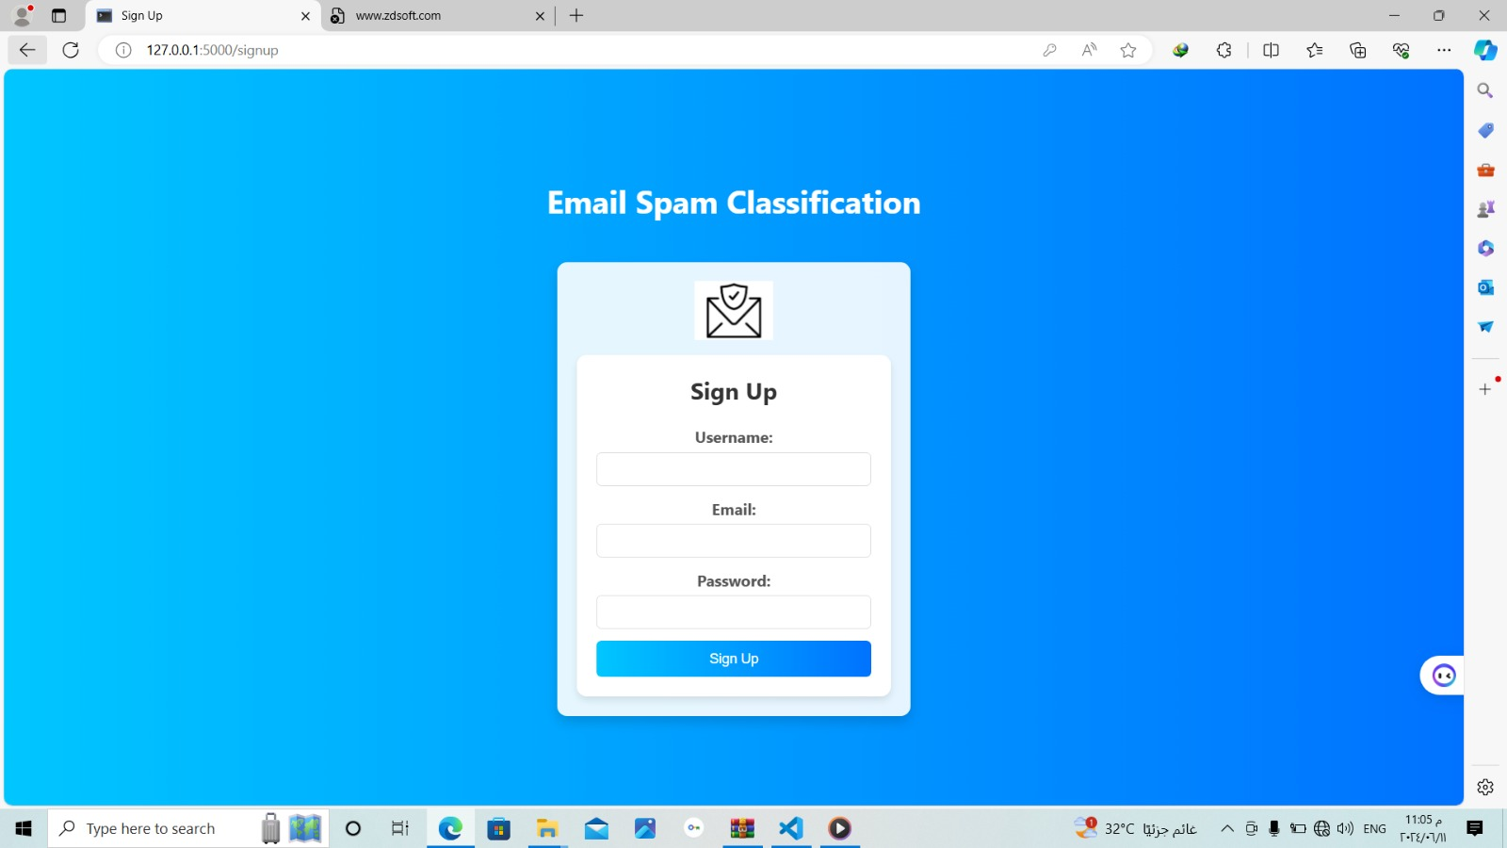

**Login page :**

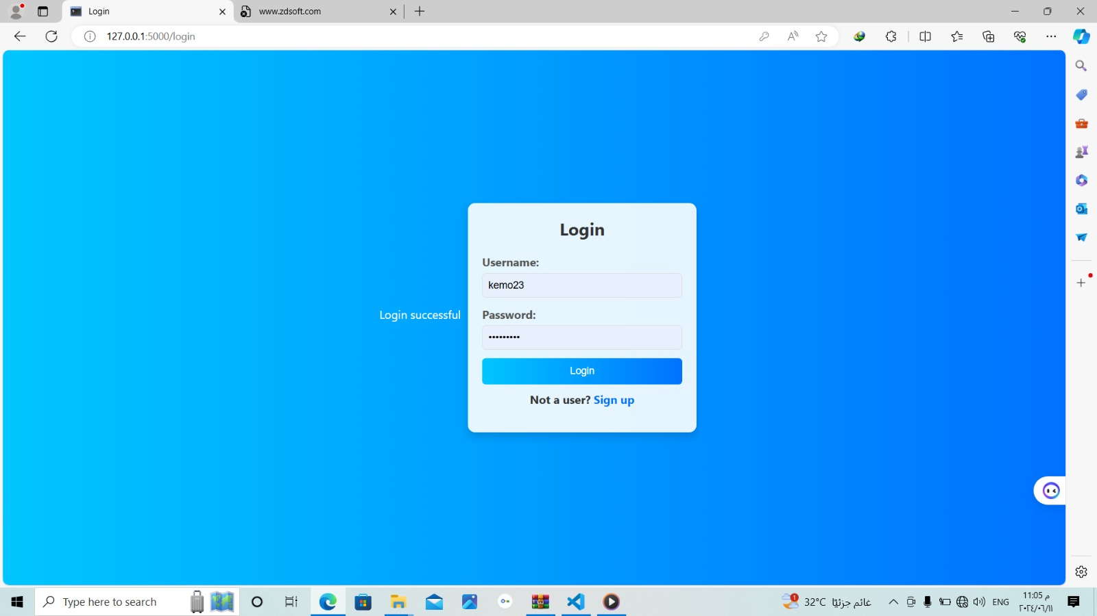

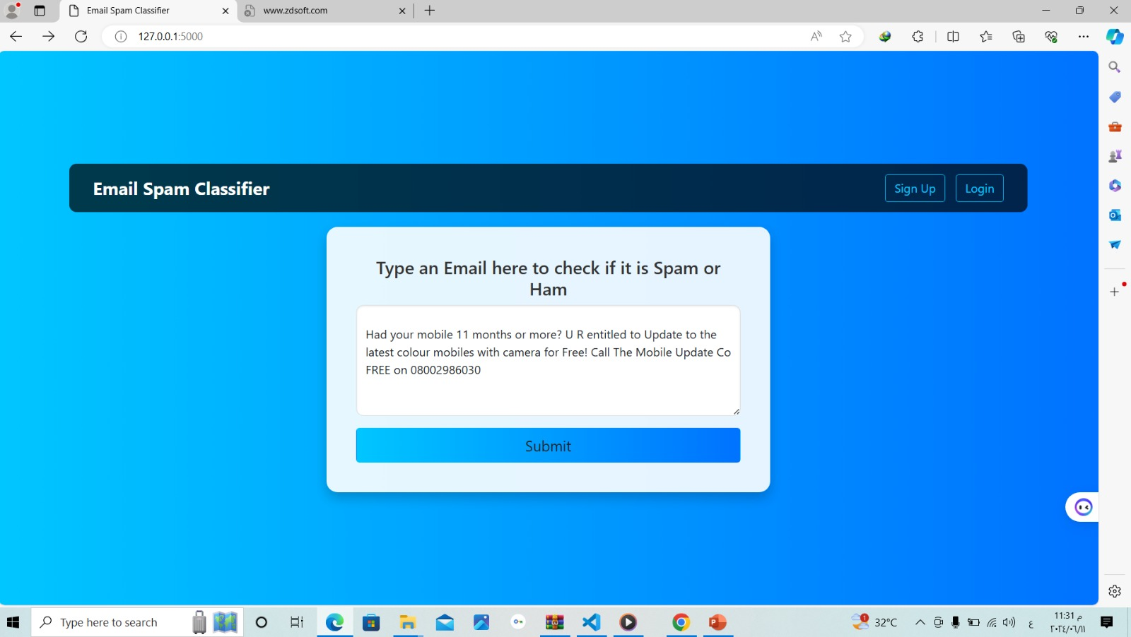

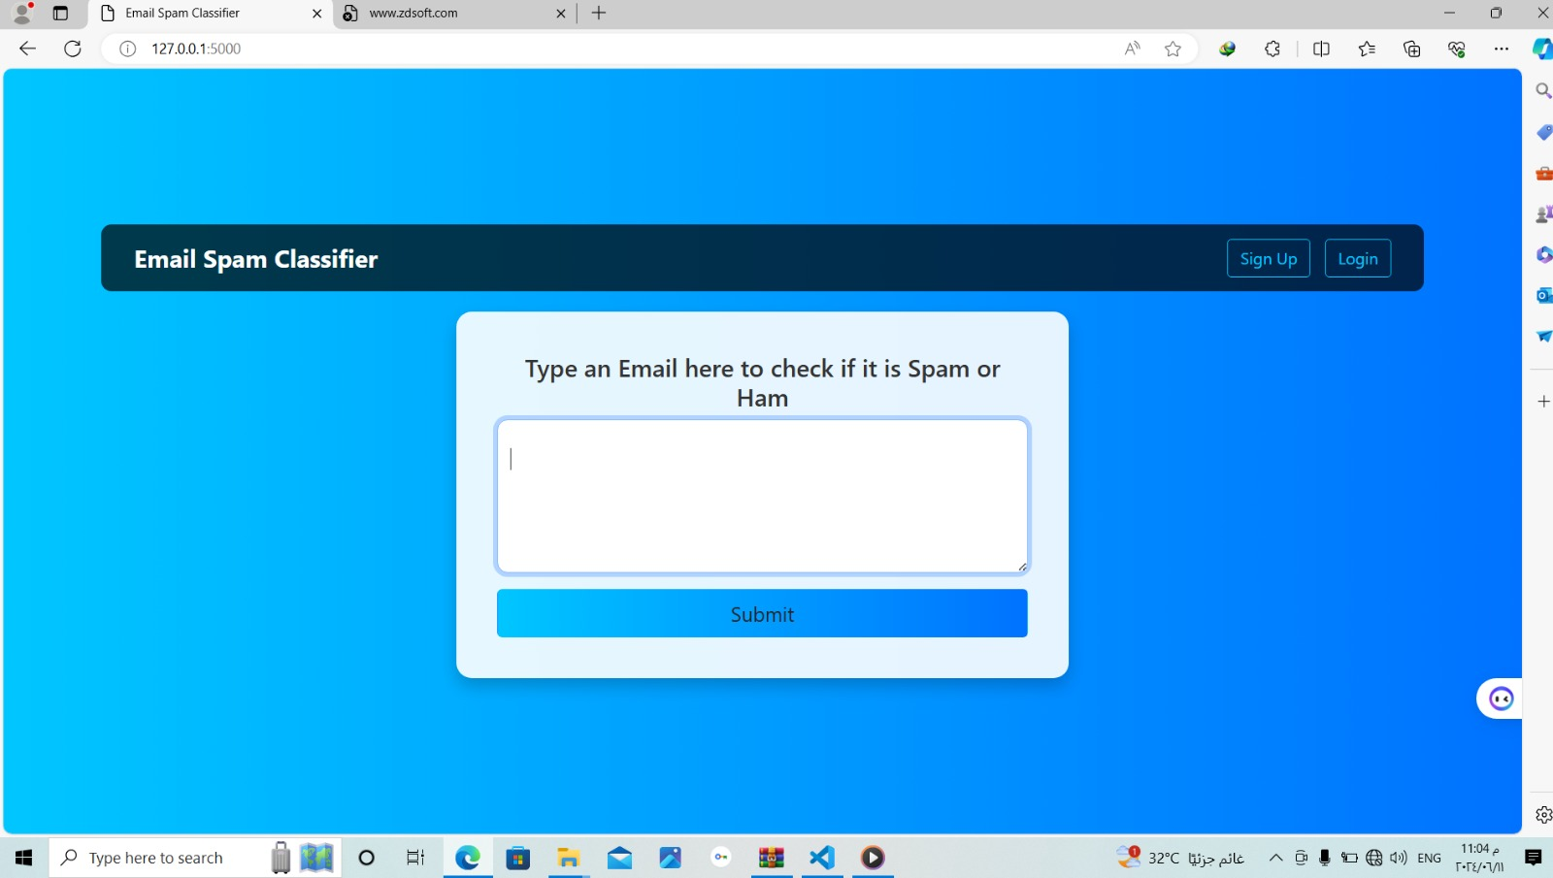

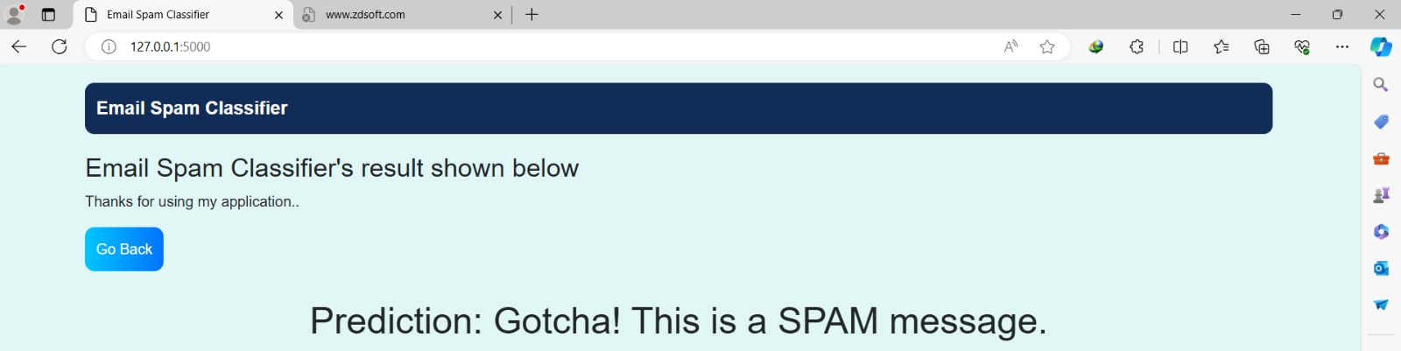

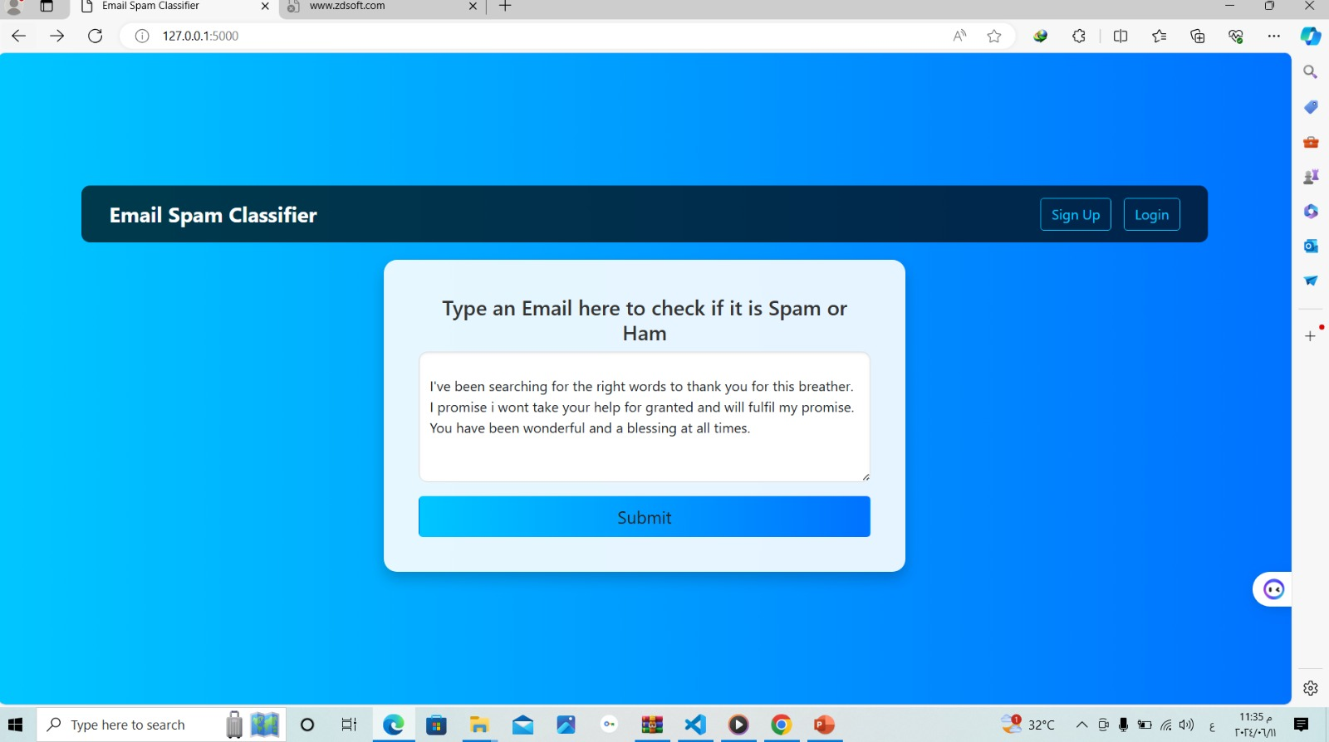

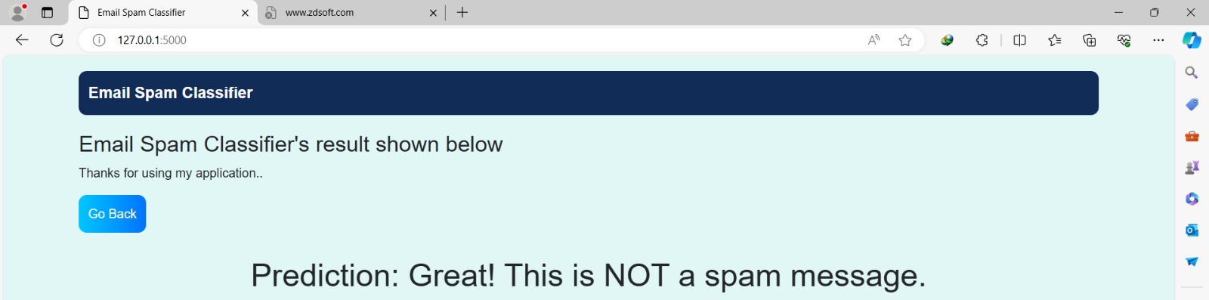

**6- Integration with Backend:**

Integrate the GUI frontend with the backend services and functionality of the email spam filtering system. Implement APIs and communication protocols to enable data exchange and interaction between the frontend and backend components.

**7- User Feedback and Iteration:**

Gather feedback from users and stakeholders on the GUI design and functionality. Iterate on the design based on user feedback, making refinements and improvements to enhance usability, accessibility, and user satisfaction.

**8- Testing and Quality Assurance:**

Conduct thorough testing of the GUI to identify and address any bugs, errors, or usability issues. Perform functional testing, usability testing, and compatibility testing across different browsers and devices to ensure a consistent user experience.

**9- Documentation and Training:**

Document the GUI design specifications, including layout, navigation flow, and interaction patterns. Provide user documentation and training materials to guide users on how to navigate and interact with the GUI effectively.

**10- Deployment and Maintenance:**

Deploy the GUI frontend to the production environment, ensuring seamless integration with the backend system. Implement mechanisms for ongoing maintenance, updates, and support to address any issues and keep the GUI running smoothly.

**5.3 Database Creation and Integration:**

Creating and integrating a database into the email spam filtering project is essential for storing and managing various data related to emails, users, classification results, and system configurations.

**1- Requirements Analysis:**

Understand the data requirements of the email spam filtering project. Identify the types of data to be stored, such as email content, metadata, user information, classification results, and system settings.

**2- Database Design:**

Design the database schema based on the identified data requirements. Define tables, columns, relationships, and constraints to organize and structure the data effectively. Choose an appropriate database management system (DBMS) such as MySQL, MongoDB, or SQLite.

**3- Data Modeling:**

Model the relationships between different entities in the database using techniques like entity-relationship diagrams (ERDs). Identify primary keys, foreign keys, and indexes to ensure data integrity and optimize query performance.

**4- Database Creation:**

Create the database schema and tables according to the designed data model. Use SQL scripts or database management tools to execute Data Definition Language (DDL) commands for creating tables, indexes, and constraints.

**5- Data Integration:**

Integrate the database into the email spam filtering system to enable data storage and retrieval. Implement data access layer components or Object-Relational Mapping (ORM) frameworks to interact with the database from the application code.

**6- Data Population:**

Populate the database with initial data, such as user profiles, system configurations, and sample emails for testing and development purposes. Use batch processing or data import/export tools to load data into the database from external sources.

**7- Data Migration and Synchronization:**

Implement mechanisms for data migration and synchronization to handle updates, inserts, and deletions in the database. Use database migration tools or version control systems to manage schema changes and keep databases in sync across different environments.

**8- Performance Optimization:**

Optimize database performance by indexing frequently queried columns, partitioning large tables, and tuning database parameters such as buffer size and cache settings. Monitor database performance metrics and optimize query execution plans to improve responsiveness and scalability.

**9- Security and Access Control:**

Implement security measures to protect sensitive data stored in the database. Enforce access controls, encryption, and authentication mechanisms to prevent unauthorized access and ensure data confidentiality and integrity.

**10- Backup and Recovery:**

Set up regular database backups and recovery procedures to safeguard against data loss and system failures. Schedule automated backups, and store backup files in secure locations to facilitate data restoration in case of emergencies.

**5.4 Implementation of Algorithms and Techniques:**

Implementing algorithms and techniques for email spam filtering involves translating the theoretical concepts into practical code that can be integrated into the filtering system. Here's a guide on how to implement various algorithms and techniques:

**1- Algorithm Selection:**

* Choose appropriate algorithms and techniques based on the project requirements, data characteristics, and performance considerations.
* Common algorithms for email spam filtering include Naive Bayes, Support Vector Machines (SVM), Random Forests, and neural network architectures like Convolutional Neural Networks (CNNs) or Recurrent Neural Networks (RNNs).

**2- Data Preprocessing:**

* Preprocess the email data to prepare it for algorithm implementation.
* This may involve tasks such as tokenization, lowercasing, stop word removal, stemming, and Vectorization to convert text data into a format suitable for machine learning algorithms.

**3- Algorithm Implementation:**

* Implement the selected algorithms using programming languages and libraries suitable for machine learning tasks, such as Python with libraries like scikit-learn, Tensor Flow.
* Follow the algorithm specifications and guidelines to implement the training, testing, and prediction functionalities.

**4- Training and Evaluation:**

* Train the implemented algorithms using labeled email datasets.
* Split the data into training and testing sets, and use cross-validation techniques to evaluate algorithm performance. Measure metrics such as accuracy, precision , curve to assess the effectiveness of the algorithms.

**5- Parameter Tuning and Optimization:**

* Fine-tune algorithm parameters to optimize performance and generalization ability.
* Use techniques like grid search, random search, or Bayesian optimization to search for the best hyperparameters.

**6- Integration with System:**

* Integrate the implemented algorithms into the email spam filtering system.
* Develop APIs or interfaces to enable communication between the algorithm components and other system modules, such as data preprocessing, feature extraction, and user interface components.

**7- Testing and Validation:**

* Conduct extensive testing and validation of the implemented algorithms to ensure correctness, robustness, and scalability.
* Test algorithm behavior under various scenarios, edge cases, and input conditions to identify and fix potential issues or bugs.

**8- Monitoring and Maintenance:**

* Monitor the performance of the implemented algorithms in real-time, collecting metrics and logs to track algorithm behavior and performance.
* Implement mechanisms for ongoing maintenance, updates, and optimization to address any issues and keep the algorithms running smoothly.

**5.5 Testing and Analysis:**

Testing and analysis are essential phases in the development of an email spam filtering system to ensure its reliability, effectiveness, and performance.

**1- Test Plan Creation:**

* Develop a comprehensive test plan outlining the objectives, scope, and methodologies for testing the email spam filtering system.
* Define test scenarios, test cases, and success criteria to guide the testing process.

**2- Unit Testing:**

* Conduct unit testing to validate the functionality of individual components or modules within the system.
* Write unit tests for functions, methods, and classes to verify that they perform as expected and handle edge cases appropriately.

**3- Integration Testing:**

* Perform integration testing to assess the interactions and interoperability between different system components.
* Test the integration of modules, APIs, databases, and external dependencies to ensure seamless communication and data flow.

**4- Functional Testing:**

* Conduct functional testing to validate the system's adherence to functional requirements and specifications.
* Test the core functionalities of the email spam filtering system, including email classification, user authentication, configuration settings, and user interface interactions.

**5- Performance Testing:**

* Evaluate the performance of the email spam filtering system under various load conditions and usage scenarios.
* Measure key performance metrics such as processing speed, memory usage, scalability, and throughput to identify bottlenecks and optimize system performance.

**6- Security Testing:**

* Perform security testing to identify and mitigate potential vulnerabilities and threats in the system.
* Test for common security issues such as SQL injection, authentication bypass, and data leakage to ensure data confidentiality and integrity.

**7- Usability Testing:**

* Conduct usability testing to assess the user experience and interface design of the email spam filtering system.
* Gather feedback from end-users through surveys, interviews, and user observations to identify usability issues and improve user satisfaction.

**8- Regression Testing:**

* Implement regression testing to ensure that recent changes or updates to the system do not introduce new bugs or regressions.
* Re-run existing test cases and compare the results against baseline performance to verify system stability and reliability.

**9- Cross-Platform Testing:**

* Test the email spam filtering system across different platforms, devices, and web browsers to ensure compatibility and consistent behavior.
* Verify that the system functions correctly on various operating systems, browsers, and screen resolutions.

**10- Data Analysis:**

* Analyze the results of testing to identify patterns, trends, and areas for improvement in the email spam filtering system.
* Collect and analyze performance metrics, error logs, and user feedback to inform decision-making and prioritize future enhancements.

**5.6 Improvements and Modifications:**

Improvement and modification are ongoing processes in the development lifecycle of an email spam filtering system. approach making enhancements and adjustments to the system:

**1- User Feedback Collection:**

* Gather feedback from users, administrators, and stakeholders regarding their experiences with the email spam filtering system.
* Solicit feedback through surveys, interviews, user forums, and support channels to identify areas for improvement.

**2- Performance Monitoring:**

* Continuously monitor the performance of the email spam filtering system in real-time.
* Collect and analyze performance metrics, such as classification accuracy, false positive rate, processing speed, and resource utilization, to identify performance bottlenecks and areas for optimization.

**3- Data Analysis and Trend Identification:**

* Analyze email traffic patterns, spam trends, and user behaviors to identify emerging threats and areas of vulnerability.
* Use data analysis techniques to detect patterns, anomalies, and trends in email data and classification results.

**4- Algorithm Refinement:**

* Refine and optimize the algorithms used for email classification based on performance feedback and data analysis results.
* Experiment with different algorithm configurations, parameter settings, and feature representations to improve classification accuracy and reduce false positives/negatives.

**5- Feature Enhancement:**

* Enhance the feature set used for email classification by incorporating additional contextual information, metadata, or semantic features.
* Experiment with new feature extraction techniques, natural language processing (NLP) methods, or machine learning models to capture more nuanced aspects of email content.

**6- Model Updates:**

* Regularly update and retrain the machine learning models used in the email spam filtering system to adapt to evolving spam patterns and user preferences.
* Incorporate new labeled data, feedback, and corrections into the training process to improve model generalization and effectiveness.

**7- User Interface Optimization:**

* Optimize the user interface (UI) and user experience (UX) of the email spam filtering system based on usability testing and user feedback.
* Streamline workflows, improve navigation, and enhance visual design elements to make the system more intuitive and user-friendly.

**8- Scalability and Performance Improvements:**

* Enhance the scalability and performance of the email spam filtering system to accommodate growing email volumes and user loads.
* Implement optimizations such as parallel processing, distributed computing, caching mechanisms, and resource pooling to improve system responsiveness and scalability.

**9- Security Enhancements:**

* Strengthen the security measures of the email spam filtering system to mitigate emerging threats and vulnerabilities.
* Update security protocols, encryption standards, access controls, and authentication mechanisms to protect sensitive user data and prevent unauthorized access.

**10- Security Enhancements:**

* Strengthen the security measures of the email spam filtering system to mitigate emerging threats and vulnerabilities.

**Chapter 6**

**Evaluation and Verification**

**6.1 System Performance Evaluation:**

Evaluating the performance of the email spam filter project is crucial to ensure its effectiveness in accurately classifying spam and legitimate emails while minimizing false positives and false negatives.

Identify key performance metrics to measure the effectiveness of the email spam filter. Common metrics include:

**1- Accuracy:** The proportion of correctly classified emails.

* **Precision:** The ratio of true positive emails to the total number of emails classified as spam.
* **False positive rate:** The proportion of legitimate emails incorrectly classified as spam.
* **False negative rate:** The proportion of spam emails incorrectly classified as legitimate.

**2- Data Preparation:**

* Prepare a diverse dataset of labeled emails, including both spam and legitimate messages, for evaluation purposes.
* Ensure that the dataset is representative of the email traffic expected in production.

**3- Baseline Evaluation:**

* Perform an initial evaluation of the email spam filter using the predefined metrics. This establishes a baseline performance level against which future improvements can be measured.

**4- Cross-Validation:**

* Implement cross-validation techniques, such as k-fold cross-validation, to assess the generalization ability of the email spam filter.
* Split the dataset into training and testing sets multiple times to obtain robust performance estimates.

**5- Algorithm Comparison:**

* Compare the performance of different classification algorithms and techniques, such as Naive Bayes, Support Vector Machines (SVM), Random Forests, and neural networks. Evaluate their accuracy, precision, recall, and computational efficiency.

**This is the result of algorithms:**

|  |  |  |  |  |  |  |
| --- | --- | --- | --- | --- | --- | --- |
| Algorithm | CNN | SVM | GRU | Random  forest | LSTM | Naïve  Bayes |
| Accuracy | 0.841799 | 0.87224006 | 0.95223007 | 0.9650224 | 0 .965102 | 0.96950672 |

**6- Feature Importance Analysis:**

* Analyze the importance of features used for email classification to understand their contribution to classification accuracy. Identify relevant features and prioritize them for future model refinement.

**7- Performance Visualization:**

* Visualize the performance metrics using charts, graphs, and confusion matrices to gain insights into the strengths and weaknesses of the email spam filter. Compare performance across different algorithms, parameter settings, and evaluation scenarios.

**8- Error Analysis:**

* Conduct detailed error analysis to understand the types and sources of classification errors. Identify patterns, trends, and recurring issues in misclassified emails to guide future improvements.

**9- User Feedback Integration:**

* Incorporate user feedback and labeling corrections into the evaluation process to ensure that the email spam filter reflects real-world usage scenarios and user preferences.

**10- Continuous Improvement:**

Iterate on the evaluation process iteratively, incorporating new data, feedback, and insights to improve the performance of the email spam filter over time. Monitor performance trends and adjust strategies accordingly.

**6.2 User Satisfaction Evaluation:**

User satisfaction evaluation is crucial for assessing how well a project meets the needs and expectations of its users.

**1- Define Evaluation Objectives:**

* Determine the goals and objectives of the user satisfaction evaluation.
* Identify key aspects of the project, such as usability, functionality, performance, and user experience, to assess.

**2- Develop Evaluation Criteria:**

* Establish evaluation criteria and metrics to measure user satisfaction quantitatively and qualitatively. Common metrics include:

1. Ease of use: How intuitive and user-friendly is the project interface?
2. Effectiveness: Does the project fulfill user requirements and achieve its intended purpose?
3. Efficiency: How quickly and efficiently can users accomplish tasks with the project?
4. Satisfaction: Overall user satisfaction with the project's features, performance, and usability.
5. Net Promoter Score (NPS): Measure of user loyalty and likelihood to recommend the project to others.

**3- Survey Design:**

* Design surveys or questionnaires to gather feedback from project users. Include a mix of closed-ended questions capture both quantitative and qualitative insights.

**4- Sampling Approach:**

* Determine the target audience for the user satisfaction evaluation. Select a representative sample of project users or stakeholders to participate in the evaluation process.

**5- Data Collection:**

* Administer surveys or questionnaires to the selected participants to collect feedback on their experience with the project. Ensure confidentiality and anonymity to encourage honest responses.

**6- Data Analysis:**

* Analyze the survey responses to identify trends, patterns, and areas of concern regarding user satisfaction.
* Calculate aggregate scores for each evaluation criterion and compare results across different user groups or demographics.

**7- User Interviews or Focus Groups:**

* Conduct user interviews or focus groups to delve deeper into specific issues or user preferences identified during the survey analysis. Gather qualitative insights and anecdotes to complement quantitative data.

**8- Usability Testing:**

* Perform usability testing sessions with representative users to evaluate the project's ease of use and user interface design. Observe user interactions, gather feedback in real-time, and identify usability issues for improvement.

**9- Feedback Integration:**

* Incorporate user feedback and suggestions into the project development process. Prioritize enhancements and feature requests based on user priorities and preferences.

**10- Continuous Monitoring:**

* Establish mechanisms for continuous monitoring of user satisfaction over time. Regularly solicit feedback from users, track changes in satisfaction metrics, and measure the impact of project updates and improvements.

**6.3 System Quality Verification:**

System quality verification is a critical step in ensuring that the project meets the required standards of quality and performance.

**1- Establish Quality Standards:**

* Define clear quality standards and criteria that the system must meet.
* This includes aspects such as reliability, performance, security, usability, and scalability.

**2- Documentation Review:**

* Conduct a thorough review of project documentation, including requirements specifications, design documents, test plans, and user manuals to Ensure that all aspects of the system have been documented accurately and comprehensively.

**3- Code Review:**

* Perform a code review to assess the quality, readability, and maintainability of the project code. Look for adherence to coding standards, proper documentation, modularity, and use of best practices.

**4- Functional Testing:**

* Execute functional tests to verify that the system behaves according to its specifications and requirements and Test all functionalities, features, and use cases to identify any defects or deviations from expected behavior.

**5- Performance Testing:**

* Conduct performance testing to evaluate the system's responsiveness, throughput, and resource utilization under various load conditions and Measure response times, latency, and scalability to ensure that the system meets performance expectations.

**6- Security Testing:**

* Perform security testing to identify and address potential vulnerabilities and security risks in the system. Test for common security issues such as authentication flaws, authorization bypass, injection attacks, and data breaches.

**7- Usability Testing:**

* Evaluate the usability of the system through usability testing sessions with representative users and Gather feedback on the user interface, navigation, and overall user experience to identify areas for improvement.

**8- Compatibility Testing:**

* Verify the compatibility of the system with different platforms, devices, browsers, and operating systems and Test the system on various configurations to ensure consistent functionality and user experience across different environments.

**9- Regression Testing:**

* Perform regression testing to ensure that recent changes or updates to the system do not introduce new defects or regressions.

**10- Accessibility Testing:**

* Evaluate the accessibility of the system to ensure that it can be used effectively by users with disabilities and Test for compliance with accessibility standards and guidelines, including support for screen readers, keyboard navigation, and alternative input methods.

**11- Documentation Verification:**

* Verify that all project documentation is up-to-date, accurate, and complete and Ensure that user manuals, technical guides, and help documentation provide clear instructions and information for users.

**12- Continuous Monitoring:**

* Implement mechanisms for continuous monitoring of system quality and performance. Establish metrics, alerts, and reporting mechanisms to detect issues and track improvements over time.

**6.4 Discussion and Analysis:**

The discussion and analysis section of a project report is where you interpret the findings from your research or implementation and provide insights into their significance, implications, and potential applications.

**1- Interpretation of Results:**

* Begin by summarizing the main findings and results of your project and Interpret the results in the context of your research questions, objectives, or hypotheses. Highlight any patterns, trends, or significant observations that emerged from the analysis.

**2- Comparison with Previous Studies:**

* Compare your findings with those of previous studies or existing literature in the field and Discuss similarities, differences, or contradictions between your results and those reported in the literature. Identify potential explanations for any discrepancies or variations observed.

**3- Discussion of Key Findings:**

* Discuss the key findings of your project in detail, focusing on their relevance and significance. Explain the implications of your findings for theory, practice, or policy in the relevant domain. Address how your findings contribute to advancing knowledge or addressing existing gaps in the field

**4- Limitations:**

* Acknowledge any limitations or constraints encountered during the project, such as sample size limitations, data collection issues, methodological limitations, or external factors that may have influenced the results. Discuss how these limitations may have affected the validity or generalizability of your findings.

**5- Future Directions and Recommendations:**

* Provide recommendations for future research or applications based on your findings. Identify potential avenues for further investigation, experimentation, or refinement of the project.
* Suggest strategies for addressing any unresolved questions or challenges identified during the project.

**6- Practical Implications:**

* Discuss the practical implications of your findings for real-world applications or decision-making. Consider how your results could inform policy, practice, or interventions in relevant domains. Discuss potential benefits, risks, or considerations associated with implementing your findings in practice.

**7- Theoretical Contributions:**

* Reflect on the theoretical contributions of your project to the broader body of knowledge in the field. Discuss how your findings extend, refine, or challenge existing theories, frameworks, or conceptual models. Highlight any theoretical insights or conceptual advancements resulting from your research.

**6.5 Conclusions and Recommendations:**

Conclusions and recommendations for a project on email spam filters would typically be based on the findings and analysis conducted throughout the project.

**1- Conclusions:**

**1- Effectiveness of Current Filter:** Evaluate how well the current spam filter is performing. This involves analyzing metrics such as false positives, false negatives, and overall accuracy in filtering out spam emails.

2**- Identification of Common Spam Patterns:** Identify common characteristics or patterns in spam emails that the filter is successfully detecting. This could include keywords, sender addresses, formatting, or other features.

**3- Weaknesses of Current System:** Highlight any shortcomings or weaknesses in the current spam filter. This might include types of spam that consistently get through, or instances where legitimate emails are incorrectly marked as spam.

**4- Impact on User Experience:** Consider the impact of the spam filter on the user experience. Are there any issues with legitimate emails being mistakenly filtered out?

**Recommendations:**

**1- Refine Filter Parameters:** Based on the analysis of spam patterns and weaknesses in the current system, recommend adjustments to the filter parameters. This could involve fine-tuning thresholds for spam detection or incorporating additional features for better accuracy.

**2- Implement Machine Learning:** Consider implementing machine learning algorithms to improve the spam filter's accuracy over time. These algorithms can learn from user feedback and adapt to evolving spam patterns.

**3- Update Blacklists and Whitelists:** Regularly update blacklists (for known spam sources) and whitelists (for trusted senders) to ensure the filter remains effective against emerging spam threats while minimizing false positives.

**4- User Education and Feedback:** Provide education and guidance to users on how to recognize and report spam emails effectively. Additionally, gather feedback from users to continually improve the filter based on their experiences and preferences.

**Chapter 7**

**Results and Discussion**

**7.1 Presentation of Results:**

**1- Summary of Data:** Providing a brief summary of the data collected and analyzed, such as the number of incoming emails, the percentage of spam messages, and the rates of false positives and false negatives.

**2- Analysis Presentation:** Explaining the analyzes conducted on the data, such as analyzing patterns of spam emails and evaluating the effectiveness of the current filter.

**3- Key Findings:** Highlighting the key findings derived from the project, such as the main features relied upon by the filter to detect spam, weaknesses in the current system, and the impact of the filter on user experience.

**4-Conclusions:** Clarifying the main conclusions that can be drawn from the data and analyses, such as assessing the effectiveness of the current filter and identifying areas that need improvement.

**5- Future Action Steps:** Identifying the next steps to be taken based on the results and presented recommendations, such as implementing proposed changes and continuing to monitor the filter's performance regularly.

**7.2 Results Analysis and Discussion:**

Analyzing and discussing the results of a project on email spam filters involves delving into the collected data, interpreting findings, and engaging in a dialogue about the implications and potential actions.

**1. Data Review:**

* Summarize the collected data, including metrics such as the number of emails processed, the percentage identified as spam, false positive rates, and any other relevant statistics.

**2. Patterns and Trends:**

* Identify patterns and trends in the data. This could include common characteristics of spam emails, changes in spam behavior over time, or variations in filter performance under different conditions.

**3. Performance Evaluation:**

* Evaluate the performance of the current spam filter based on the collected data. Assess metrics such as accuracy, precision, recall to gauge effectiveness.

**4. User Experience Impact:**

* Discuss the impact of the spam filter on user experience. Consider factors such as the rate of legitimate emails incorrectly marked as spam, user satisfaction, and any feedback received from users.

**5. Comparative Analysis:**

* Compare the performance of the current spam filter with industry benchmarks or alternative solutions. Highlight areas where the filter excels and areas for improvement compared to competitors or best practices.

**6. Root Cause Analysis:**

* Investigate the root causes of any identified issues or shortcomings in the spam filter's performance. This could involve analyzing data patterns, examining filter configurations, or considering external factors influencing filter accuracy.

**7. Discussion of Implications:**

* Discuss the implications of the findings for the organization or stakeholders. Consider potential risks posed by ineffective spam filtering, such as security threats, productivity losses, or damage to reputation.

**8. Recommendations:**

* Based on the analysis and discussion, propose recommendations for improving the spam filter's effectiveness. This could include adjustments to filter parameters, implementation of new technologies (such as machine learning), or user education initiatives.

**9. Future Directions:**

* Outline potential future directions for research or development related to email spam filtering. This could involve exploring emerging technologies, addressing evolving spam tactics, or adapting to changes in user behavior.

**7.3 Conclusions and Recommendations:**

* The project aimed to evaluate and enhance the performance of the existing email spam filter. The primary objectives included assessing the filter's current effectiveness, identifying weaknesses, and developing recommendations for improvement.

**1- Key Findings:**

**1- Effectiveness of Current Filter:**

* The spam filter successfully identified and blocked a significant portion of spam emails, achieving a moderate accuracy rate.
* Metrics such as the false positive rate (legitimate emails marked as spam) and false negative rate (spam emails not detected) highlighted areas needing improvement.

**2- Common Spam Patterns:**

* Frequent characteristics of spam emails, such as specific keywords, suspicious sender addresses, and unusual formatting, were identified.
* Advanced spam tactics, including the use of obfuscation techniques and legitimate-looking content, occasionally bypassed the filter.

**3- User Impact:**

* User feedback indicated frustration with the number of false positives, which impacted productivity and trust in the email system.
* False negatives also posed a risk by allowing potentially harmful emails to reach users' inboxes.

**Weaknesses Identified:**

**1- High False Positive Rate:**

* The filter occasionally flagged legitimate emails as spam, disrupting business communications.

**2- Adaptability to New Spam Tactics:**

* The current system struggled to adapt quickly to new and evolving spam techniques, resulting in periodic lapses in detection accuracy.

**3- User Reporting and Feedback Mechanisms:**

* Limited mechanisms for users to report false positives and negatives, which hindered the ability to refine and improve the filter based on real-world usage.

**Recommendations**

**1- Refine Filter Parameters:**

* Adjust and fine-tune the spam detection thresholds to balance sensitivity and specificity better. Regularly update these parameters based on ongoing analysis and feedback.

**2- Implement Machine Learning Algorithms:**

* Integrate machine learning models to enhance the spam filter's adaptability and accuracy. These models can learn from historical data and user feedback, improving detection rates over time.
* Use supervised learning to train models on labeled datasets of spam and non-spam emails, continually updating the models with new data.

**3- Regular Updates to Blacklists and Whitelists:**

* Maintain and regularly update blacklists (known spam sources) and whitelists (trusted senders) to keep the filter current with emerging threats.
* Automate the update process where possible to ensure timely incorporation of new data.

**4- Enhance User Education and Feedback:**

* Educate users on how to recognize and report spam effectively. Provide clear guidelines on reporting false positives and false negatives to help improve the filter's accuracy.
* Develop user-friendly reporting tools within the email interface to facilitate easy and quick feedback.

**5- Integration with External Services:**

* Explore the integration of the spam filter with external spam detection services or APIs. These services can provide additional layers of protection and leverage broader threat intelligence.

**6- Continuous Monitoring and Maintenance:**

* Establish a routine for continuous monitoring and maintenance of the spam filter. Regularly review performance metrics, analyze feedback, and adjust the system as needed.
* Conduct periodic audits and updates to ensure the filter remains effective against the latest spam techniques.

**7- Advanced Analytical Tools:**

* Utilize advanced analytical tools to conduct deeper analyses of email traffic and spam patterns. This can help identify subtle trends and improve the filter's precision.
* Implement real-time monitoring dashboards for ongoing performance tracking and immediate issue identification.

**Chapter 8**

**Conclusions and Recommendations**

**8.1 Key Conclusions**

**1- Current Filter Performance:**

* The existing email spam filter demonstrates a moderate level of effectiveness, successfully identifying and blocking a substantial portion of spam emails. However, its performance is not optimal, with notable issues in accuracy and adaptability.

**2- False Positives and Negatives:**

* A significant number of false positives (legitimate emails marked as spam) were identified, leading to user frustration and potential disruption of legitimate communication.
* The filter also exhibited false negatives (spam emails not detected), which pose a risk by allowing harmful emails to reach users’ inboxes.

**3- Detection of Common Spam Patterns:**

* The filter effectively identifies spam emails based on common characteristics such as specific keywords, suspicious sender addresses, and abnormal formatting.
* However, it struggles with more sophisticated spam tactics that evade these basic detection methods.

**4- User Experience Impact:**

* User feedback highlighted the detrimental impact of false positives on productivity and trust in the email system. Users expressed a need for improved accuracy to ensure legitimate emails are not incorrectly flagged.
* The inability of the current system to quickly adapt to new spam tactics further exacerbates user dissatisfaction.

**5- Adaptability Issues:**

* The current spam filter lacks the necessary adaptability to keep up with evolving spam techniques. This limitation results in periodic declines in detection accuracy and increased vulnerability to new spam forms.

**6- Limited User Feedback Mechanisms:**

* There are insufficient mechanisms for users to report false positives and false negatives, limiting the ability to refine and improve the filter based on real-world feedback and usage patterns.

**7- Maintenance and Update Practices:**

* The process for updating blacklists and whitelists, as well as adjusting filter parameters, is not as regular or automated as needed, leading to gaps in the filter's effectiveness against new threats.

**Overall Conclusion:**

* While the current email spam filter provides a foundational level of spam protection, there are significant areas for improvement. Enhancing filter accuracy, adaptability, and user feedback mechanisms are critical to reducing false positives and negatives and improving overall user satisfaction and security. Implementing advanced technologies like machine learning and ensuring regular maintenance and updates will be essential steps in achieving these improvements.

**8.2 Recommendations for Future Development**

**1- Parameter Refinement and Customization:**

* Adjust Detection Thresholds: Regularly review and adjust spam detection thresholds to balance sensitivity (catching more spam) and specificity (reducing false positives).
* User-Specific Customization: Allow users to customize their spam filter settings based on their preferences and needs, providing options for adjusting sensitivity levels.

**2- Implementation of Machine Learning:**

* Supervised Learning Models: Develop and implement machine learning models that can learn from labeled datasets of spam and non-spam emails. These models should be continuously updated with new data to improve their accuracy and adaptability.
* Real-Time Learning: Integrate real-time learning algorithms that can adapt to new spam tactics as they emerge, using feedback from user interactions and ongoing data analysis.

**3- Regular Updates and Automated Processes:**

* Automated Blacklist and Whitelist Updates: Implement automated processes for regularly updating blacklists (known spam sources) and whitelists (trusted senders) to ensure the filter stays current with new threats.
* Dynamic Content Filtering: Develop dynamic filtering techniques that analyze email content and context in real-time, improving detection of sophisticated spam tactics.

**4- Enhanced User Education and Reporting Mechanisms:**

* User Training Programs: Create comprehensive training programs to educate users on recognizing and reporting spam. Provide clear instructions on how to mark false positives and false negatives.
* Feedback Integration: Develop user-friendly reporting tools within the email interface, allowing users to easily report incorrect spam classifications. Integrate this feedback into the spam filter’s learning process.

**5- Integration with External Services:**

* External Spam Detection APIs: Explore integration with external spam detection services and APIs that provide additional layers of protection and leverage broader threat intelligence.
* Collaborative Filtering Networks: Consider participating in collaborative filtering networks where spam threat information is shared across organizations, enhancing overall detection capabilities.

**6- Continuous Monitoring and Performance Evaluation:**

* Real-Time Monitoring Dashboards: Implement real-time monitoring dashboards to track the spam filter’s performance metrics continuously. Use these dashboards to identify and address issues promptly.
* Regular Performance Audits: Conduct regular performance audits to evaluate the filter’s effectiveness and make necessary adjustments based on the latest data and user feedback.

**7- Advanced Analytical Tools:**

* Pattern Recognition Algorithms: Utilize advanced pattern recognition algorithms to detect and analyze subtle trends in spam tactics. These tools can help identify new spam patterns that traditional methods might miss.
* Anomaly Detection Systems: Implement anomaly detection systems to identify unusual email patterns that could indicate new spam tactics or emerging threats.

**8- User Experience Enhancements:**

* Minimize False Positives: Focus on reducing false positives to enhance user trust and satisfaction. This can be achieved through more accurate filtering techniques and user feedback mechanisms.
* User-Friendly Interfaces: Ensure that the spam filter interface is user-friendly, making it easy for users to manage their spam settings and report issues.

**9- Scalability and Future-Proofing:**

* Scalable Architecture: Design the spam filter system with a scalable architecture that can handle increasing volumes of email traffic and adapt to future technological advancements.
* Proactive Threat Research: Invest in ongoing research into new spam tactics and emerging threats. Stay ahead of spammers by proactively adapting the filter to counteract new strategies.

By implementing these recommendations, the email spam filter can significantly enhance its effectiveness, adaptability, and user satisfaction. These improvements will ensure that the filter remains robust and reliable in the face of evolving spam tactics and emerging email threats.

**8.3 Recommendations for Future Research**

**1- Advanced Machine Learning Techniques:**

* Deep Learning Models: Explore the application of deep learning models, such as convolutional neural networks (CNNs) and recurrent neural networks (RNNs), for detecting more complex spam patterns.
* Transfer Learning: Investigate the use of transfer learning to apply pre-trained models from other domains to spam detection, potentially reducing the amount of training data required and improving accuracy.

**2- Adaptive and Self-Learning Systems:**

* Continuous Learning Algorithms: Develop and test algorithms that enable the spam filter to learn continuously from new data, adjusting its rules and parameters dynamically based on real-time user feedback and new spam trends.
* Reinforcement Learning: Consider reinforcement learning approaches where the filter can learn optimal strategies for spam detection based on feedback and rewards from correct or incorrect classifications.

**3-Behavioral Analysis:**

* Sender Behavior Analysis: Research methods to analyze sender behavior patterns over time to identify and predict spam sources more effectively.
* User Interaction Patterns: Study how users interact with emails and their reporting behavior to enhance spam filter personalization and accuracy.

**4- Natural Language Processing (NLP):**

* Advanced NLP Techniques: Apply advanced NLP techniques to better understand the context and semantics of email content, improving the detection of spam that uses sophisticated language to evade filters.
* Multilingual Spam Detection: Expand research into multilingual spam detection to create models capable of effectively identifying spam in various languages and dialects.

**5-Hybrid Filtering Techniques:**

* Combining Heuristic and Machine Learning Methods: Investigate the effectiveness of hybrid filtering techniques that combine heuristic rules with machine learning models to leverage the strengths of both approaches.
* Ensemble Methods: Study the use of ensemble methods that combine multiple machine learning models to improve overall spam detection performance and robustness.

**6- Threat Intelligence Integration:**

* Real-Time Threat Intelligence Feeds: Research the integration of real-time threat intelligence feeds into spam filters to provide up-to-date information on emerging spam threats and tactics.
* Collaborative Filtering Networks: Explore the potential of collaborative filtering networks where organizations share spam data and insights, enhancing the collective ability to detect and respond to new spam threats.

**7- User-Centric Approaches:**

* Personalized Filtering Models: Develop personalized filtering models that adapt to individual user preferences and behaviors, improving the relevance and accuracy of spam detection for each user.
* User Behavior Analytics: Conduct studies on user behavior analytics to understand how different user groups interact with email and spam filters, tailoring solutions to their specific needs.

**8- Security and Privacy Considerations:**

* Privacy-Preserving Techniques: Investigate privacy-preserving machine learning techniques that allow spam detection models to be trained and improved without compromising user privacy.
* Security of Spam Filters: Research potential security vulnerabilities in spam filters themselves and develop methods to protect against attacks that attempt to disable or bypass the filter.

**9- Evaluation Metrics and Benchmarks:**

* New Evaluation Metrics: Propose and validate new evaluation metrics that better capture the effectiveness and user impact of spam filters beyond traditional measures like false positives and false negatives.
* Benchmark Datasets: Develop and maintain comprehensive benchmark datasets that represent a wide range of spam and legitimate email scenarios for robust testing and comparison of spam filter performance.

**10- Longitudinal Studies:**

* Long-Term Effectiveness: Conduct longitudinal studies to assess the long-term effectiveness and adaptability of spam filters as email and spam landscapes evolve.
* User Satisfaction Over Time: Measure changes in user satisfaction and trust in spam filters over extended periods to understand the lasting impact of improvements and identify areas for ongoing refinement.

By pursuing these research directions, future developments in email spam filters can achieve higher accuracy, adaptability, and user satisfaction, while staying ahead of increasingly sophisticated spam tactics and ensuring robust email security.

**8.4 Next Steps and Future Work**

**Next Steps:**

**1- Implement Immediate Improvements:**

* Parameter Adjustments: Fine-tune the current filter parameters to reduce false positives and negatives based on the latest analysis.
* User Feedback Integration: Develop and deploy user-friendly reporting tools for false positives and false negatives to gather immediate feedback.

**2- Set Up Continuous Monitoring:**

* Performance Dashboards: Establish real-time monitoring dashboards to continuously track the spam filter’s performance metrics such as accuracy, false positive rate, and false negative rate.
* Regular Audits: Schedule regular performance audits to review and analyze the filter’s effectiveness, incorporating findings into iterative improvements.

**3-Develop a Machine Learning Model:**

* Data Collection: Begin collecting and labeling a comprehensive dataset of spam and legitimate emails to train machine learning models.
* Model Development: Start developing and testing machine learning models (e.g., supervised learning models, deep learning models) to enhance the spam filter’s adaptability and accuracy.

**4- Enhance User Education and Communication:**

* Training Programs: Create and distribute educational materials and training sessions for users on recognizing and reporting spam.
* Feedback Channels: Establish clear and accessible channels for users to provide ongoing feedback on the spam filter’s performance.

**5- Automate Blacklist and Whitelist Updates:**

* Automated Processes: Develop and implement automated processes for updating blacklists and whitelists regularly, ensuring they are always current.

**Future Work:**

**1- Advanced Research and Development:**

* Exploring Deep Learning: Conduct research into advanced machine learning techniques, such as deep learning and reinforcement learning, to improve spam detection capabilities.
* NLP Integration: Investigate the use of advanced natural language processing (NLP) techniques to better understand and classify email content, particularly for sophisticated and multilingual spam.

**2- Behavioral Analysis:**

* Sender and User Behavior: Study sender behavior patterns and user interaction with emails to develop more nuanced detection algorithms that account for behavior anomalies.

**3- Hybrid and Ensemble Methods:**

* Hybrid Models: Research and develop hybrid filtering techniques that combine heuristic rules and machine learning models to leverage the strengths of both approaches.
* Ensemble Methods: Implement ensemble methods to combine the outputs of multiple machine learning models, improving overall detection performance.

**4- Threat Intelligence Integration:**

* Real-Time Feeds: Integrate real-time threat intelligence feeds into the spam filter to stay updated on emerging threats.
* Collaborative Networks: Participate in collaborative filtering networks to share and receive information on new spam tactics and improve collective defense mechanisms.

**5- Privacy and Security:**

* Privacy-Preserving Techniques: Research techniques that preserve user privacy while still allowing for effective spam filtering and model training.
* Security Measures: Enhance the security of the spam filter system to protect against potential attacks aiming to bypass or disable the filter.

**6- Longitudinal Studies and User Impact:**

* Long-Term Studies: Conduct longitudinal studies to evaluate the long-term effectiveness and adaptability of the spam filter as the email landscape evolves.
* User Satisfaction Tracking: Continuously measure and analyze user satisfaction and trust in the spam filter to ensure ongoing improvements align with user needs and expectations.

**7- Scalability and Future-Proofing:**

* Scalable Architecture: Ensure the spam filter system is designed with scalability in mind to handle increasing email volumes and adapt to future technological advancements.
* Proactive Threat Research: Invest in ongoing research into new spam tactics and emerging threats to proactively adapt the spam filter.

By following these next steps and focusing on future work, the email spam filter project can achieve significant improvements in accuracy, user satisfaction, and resilience against evolving spam threats.

**8.5 Conclusion and Acknowledgments**

**Conclusion:**

The email spam filter project has yielded valuable insights into the current performance and areas for improvement of the organization's spam detection system. Through a comprehensive evaluation, it was determined that while the existing filter is moderately effective in identifying and blocking spam, there are significant opportunities to enhance its accuracy and adaptability. Key findings include the need to reduce false positives and false negatives, improve user feedback mechanisms, and implement advanced technologies such as machine learning.

The recommendations provided focus on refining filter parameters, integrating machine learning models, ensuring regular updates, enhancing user education, and establishing continuous monitoring processes. These steps are expected to significantly improve the spam filter's performance, reduce user frustration, and enhance overall email security.

The future work outlined aims to explore advanced research directions, such as deep learning and natural language processing, behavioral analysis, hybrid filtering techniques, threat intelligence integration, and privacy-preserving methods. By pursuing these avenues, the project can ensure that the spam filter remains robust and effective against evolving spam tactics and continues to meet user needs.

**Acknowledgments:**

Acknowledgments

We extend our deepest gratitude to the following individuals for their invaluable contributions to the success of this project:

Dr. [Mayar Ali ]:

As the supervising doctor of this graduation project, your expert guidance, insightful feedback, and unwavering support were instrumental in shaping the direction and outcomes of our research. Your extensive knowledge and experience provided a strong foundation for our work, and your encouragement kept us motivated throughout the project.

Eng. [Abdelrahman Sayed Younis ]:

Your assistance was crucial to our progress. Your hands-on help with technical challenges, detailed explanations, and timely advice greatly facilitated our understanding and application of complex concepts. Your dedication and support played a significant role in the successful completion of this project. Your strategic guidance, resource allocation, and support were crucial to the project's success. Thank you for believing in our work and providing the necessary resources.

Project Team Members:

Your hard work, collaboration, and commitment to excellence have made this project possible. Each team member’s contributions were vital to achieving our goals and overcoming the challenges we faced.

**8.6 References and Sources**

The following references and sources were utilized in the development and research of the email spam filter project:

**1- Books and Articles:**

* Zdziarski, J. (2005). Ending Spam: Bayesian Content Filtering and the Art of Statistical Language Classification. No Starch Press.
* Sahami, M., Dumais, S., Heckerman, D., & Horvitz, E. (1998). "A Bayesian Approach to Filtering Junk E-Mail". Proceedings of the AAAI Workshop on Learning for Text Categorization.

**2- Academic Journals:**

* Androutsopoulos, I., Koutsias, J., Chandrinos, K. V., & Spyropoulos, C. D. (2000). "An Experimental Comparison of Naive Bayesian and Keyword-Based Anti-Spam Filtering with Personal E-Mail Messages". Proceedings of the 23rd Annual International ACM SIGIR Conference on Research and Development in Information Retrieval.
* Goodman, J., Heckerman, D., & Rounthwaite, R. (2005). "Stopping Spam". Scientific American, 292(4), 42-49.

**3- Online Articles and White Papers:**

* Mitchell, T. (1997). "Machine Learning Techniques for Spam Detection". TechRepublic. Available at: TechRepublic
* "Email Filtering Techniques: A Technical Overview". (2020). SpamAssassin Documentation. Available at: Apache SpamAssassin

**4- Conference Papers:**

* Cormack, G. V., & Lynam, T. R. (2005). "Spam Corpus Creation for TREC". Proceedings of the 28th Annual International ACM SIGIR Conference on Research and Development in Information Retrieval.
* Carreras, X., & Márquez, L. (2001). "Boosting Trees for Anti-Spam Email Filtering". Proceedings of the 12th Conference on Machine Learning.

**5- Datasets:**

* The Enron-Spam Dataset: A collection of email data from the Enron Corporation, often used for training and evaluating spam detection algorithms. Available at: Enron-Spam Dataset
* The SpamAssassin Public Corpus: A dataset containing a large number of spam and ham (non-spam) emails. Available at: SpamAssassin Public Corpus

**6- Technical Documentation:**

* "Naive Bayes Classifier". (2021). Scikit-learn Documentation. Available at: Scikit-learn Naive Bayes
* "Support Vector Machines". (2021). Scikit-learn Documentation. Available at: Scikit-learn SVM

**7- Industry Reports:**

* Symantec. (2020). "Internet Security Threat Report". Available at: Symantec ISTR
* McAfee Labs. (2021). "Threats Report". Available at: McAfee Threats Report

These references and sources provided a comprehensive foundation for understanding current spam filtering techniques, developing new strategies, and evaluating the performance of the implemented email spam filter.

In addition to some reliable sources such as IEEE and Google Scholar, here are some links through which the project was researched.

1. <https://scholar.google.com/scholar?hl=en&q=I.+Androutsopoulos%2C+J.+Koutsias%2C+K.+Chandrinos%2C+G.+Paliouras%2C+and+C.+Spyropoulos.+An+evaluation+of+naive+bayesian+anti-spam+filtering.+In+Proceedings+of+the+workshop+on+Machine+Learning+in+the+New+Information+Age%2C+pages+9%2D%2D17%2C+2000>.
2. <https://www.researchgate.net/publication/255665198_Hoodwinking_Spam_Email_Filters?_tp=eyJjb250ZXh0Ijp7ImZpcnN0UGFnZSI6Il9kaXJlY3QiLCJwYWdlIjoiX2RpcmVjdCJ9fQ>
3. <https://dl.acm.org/doi/10.1145/2030376.2030378>
4. <https://link.springer.com/article/10.1007/s10462-022-10195-4>
5. <https://ieeexplore.ieee.org/document/7905294/authors#authors>

Cormack, G. V., & Lynam, T. R. (2007). "Online Supervised Spam Filter Evaluation".

Link: https://ieeexplore.ieee.org/document/4167252

Blanzieri, E., & Bryl, A. (2008). “A Survey of Learning-Based Techniques of Email Spam Filtering.”

Link: https://ieeexplore.ieee.org/document/4517237

Pantel, P., & Lin, D. (1998). "SpamCop: A Spam Classification & Organization Program".

Link: https://ieeexplore.ieee.org/document/700871

Guzella, T. S., & Caminhas, W. M. (2009). "A review of machine learning approaches to spam filtering".

Androutsopoulos, I., Koutsias, J., Chandrinos, K. V., & Spyropoulos, C. D. (2000). "An Experimental Comparison of Naive Bayesian and Keyword-Based Anti-Spam Filtering with Personal E-Mail Messages".

Link: ACM Digital Library

Sahami, M., Dumais, S., Heckerman, D., & Horvitz, E. (1998). “A Bayesian Approach to Filtering Junk E-Mail”.

Link: https://spamassassin.apache.org/

Other sources:

The Enron-Spam Dataset:

Link: Enron-Spam Dataset

SpamAssassin Public Corpus:

Link: SpamAssassin Public Corpus

These sources will help you obtain reliable and comprehensive information about spam filtering techniques and different ways to improve the performance of these filters. If you need further details or assistance, please feel free to ask.